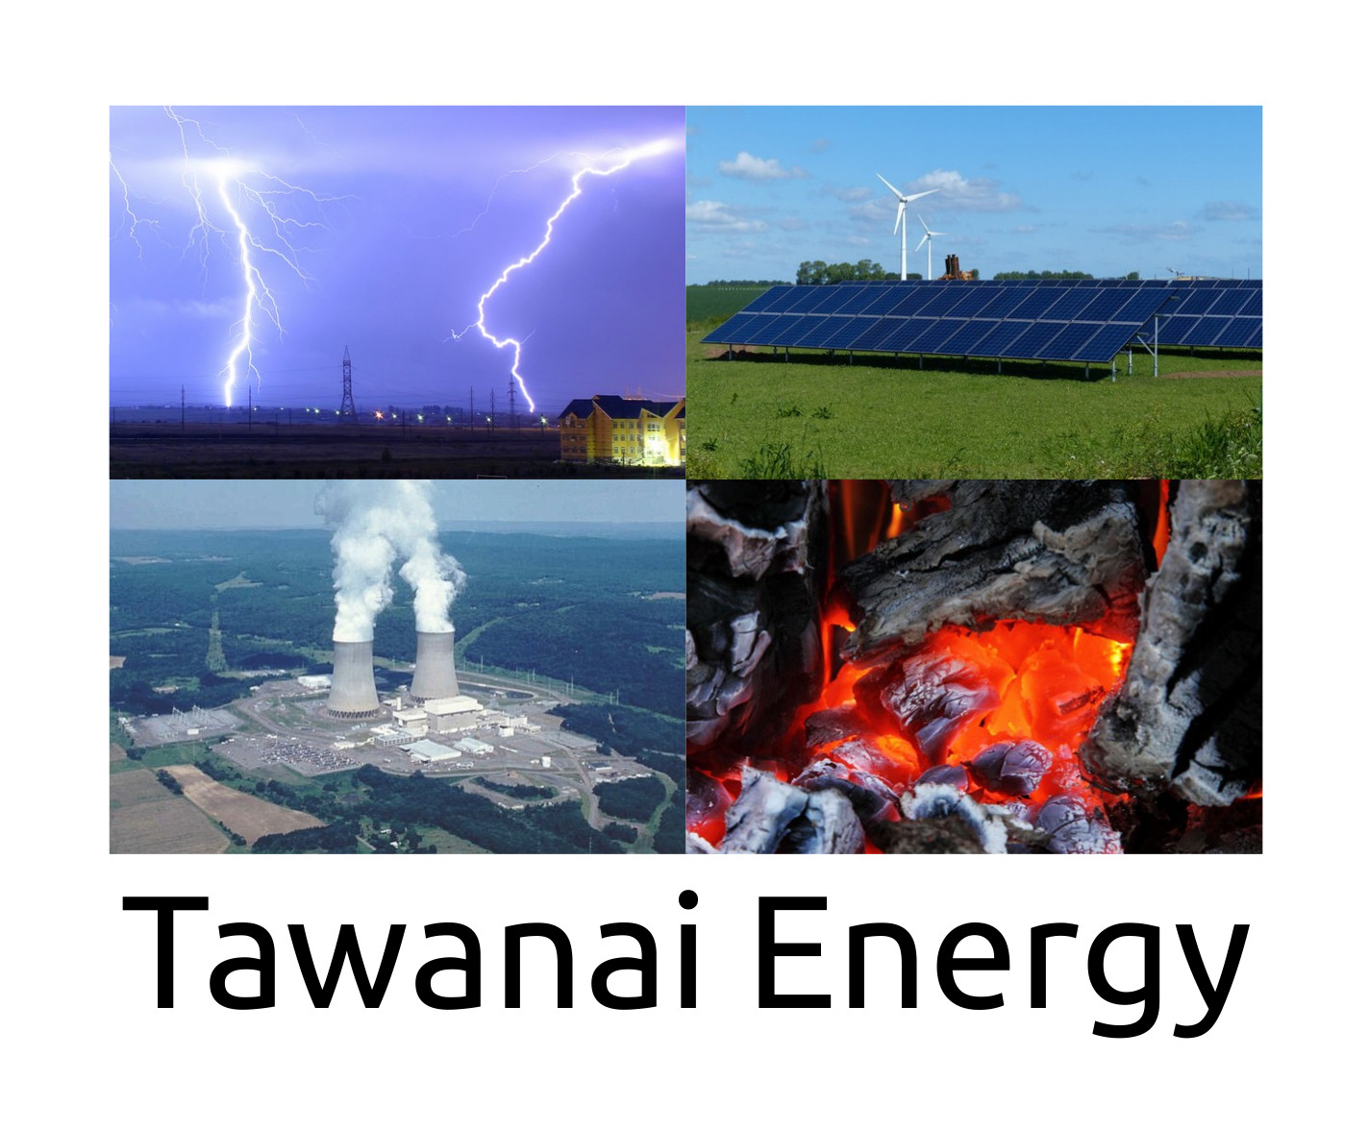
Reliable power for existing generator users.

Large home and office 5kw solution.

All items included with installation.

Prices and estimates are based on our own experience gained from actual installed and delivered systems.
You shall be charged the actual costs because our project management charges are fixed and separated from the items in the project.

5KW inverter hybrid

48V Battery 280 Ah

460 watt modules x 4 for 1840 watt array.
Updated on : 20 April 2022
Updated on : 19 June 2022
Fixed Amounts :
Project management : Rs 75,000
Electrician : Rs. 75,000
Inverter : Rs 77,500
MaxPower Sunglow VMll 5KW ₨ 77,500
MaxPower 5KW INFINI VII ₨ 84,525
Solar Module Frames : Rs 12,000

Batteries : Rs 110,000
Phoenix Tubular Lead Acid Battery TX3500 09 Plates 280 Ah
52,000 x 4 = 108,000 + 2,000 transport = 110,000
http://web3.atrc.net.pk/products/tawanai/batteries/tawanai%20battery%20prices%2017%20june%202022-1.pdf
Wooden box cover for batteries : Rs 40,000
Solar Modules : Rs 128,800 + 5000 transportation = 133,800
75000 + 75000 + 77500 + 12000 + 110000 + 40000 + 133800 = \
Rs. 523,300
Fixed total : Rs. 523,300
Ranges :
DC breakers, fuses and wiring : Rs 10,000 – Rs. 20,000
AC Wiring, parts and wiring fix range : Rs. 30,000 to Rs. 120,000
Solar Array wiring range : Rs 20,000 – Rs 50,000
Ranges minimum : 50,000 Maximum : 190,000. Difference = 140,000
Total range :
Minimum : 523,300 + 50,000 = 573,300
Maximum : 523,300 + 190,000 = 713,300
1 Ton split air conditioner inverter based with UPS option Rs. 100,000
Contact : + 92 343 270 2932
Email tawanai@atrc.net.pk
Web : http://atrc.net.pk/tawanai

This system shall save about Rs 300 per day and has an ROI of about 5.4 years if there is no utility power failure.
If the load shedding is 5 hours per day and you used a diesel generator to cope, then this system shall save about Rs 500 per day and has shall have an ROI of about 3.3 years.
These estimates are based on our experience. Please understand that it is an estimate and based on our measurements of delivered systems so far.
Every system and case is different and the savings could be more or less depending on how it is used and how much load shedding occurs in your area.
We can upgrade the system to meet any unexpected developments which were not known during the design and implementation phase of the system.

