

Submersible Pump Solutions

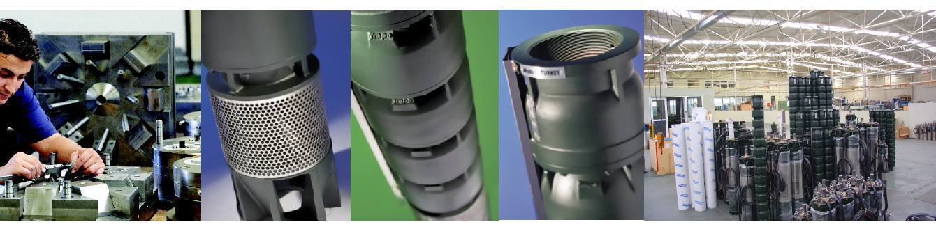
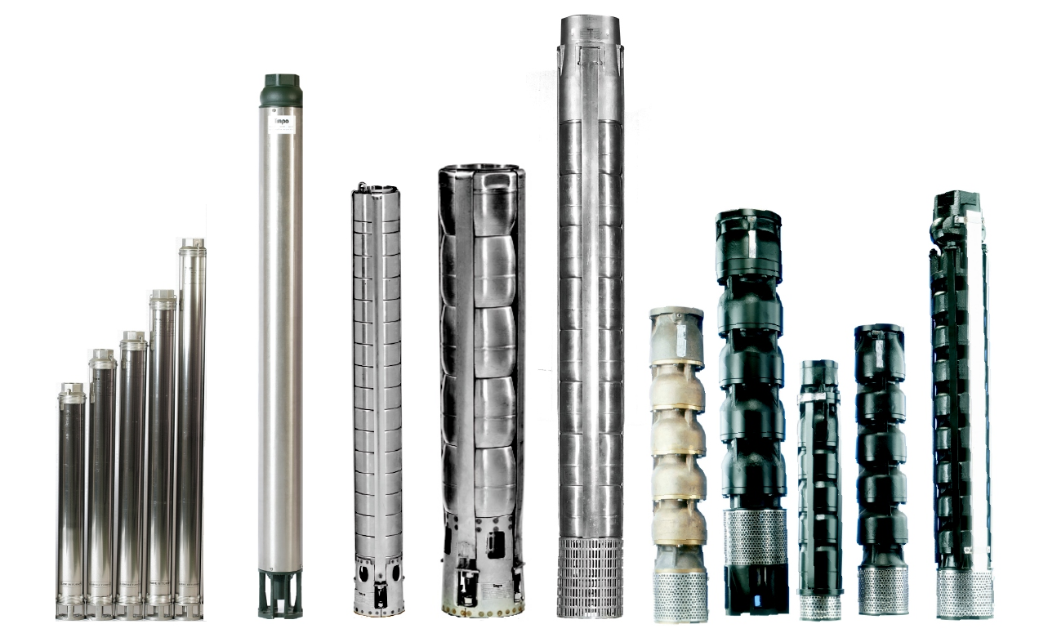

Noryl Pumps
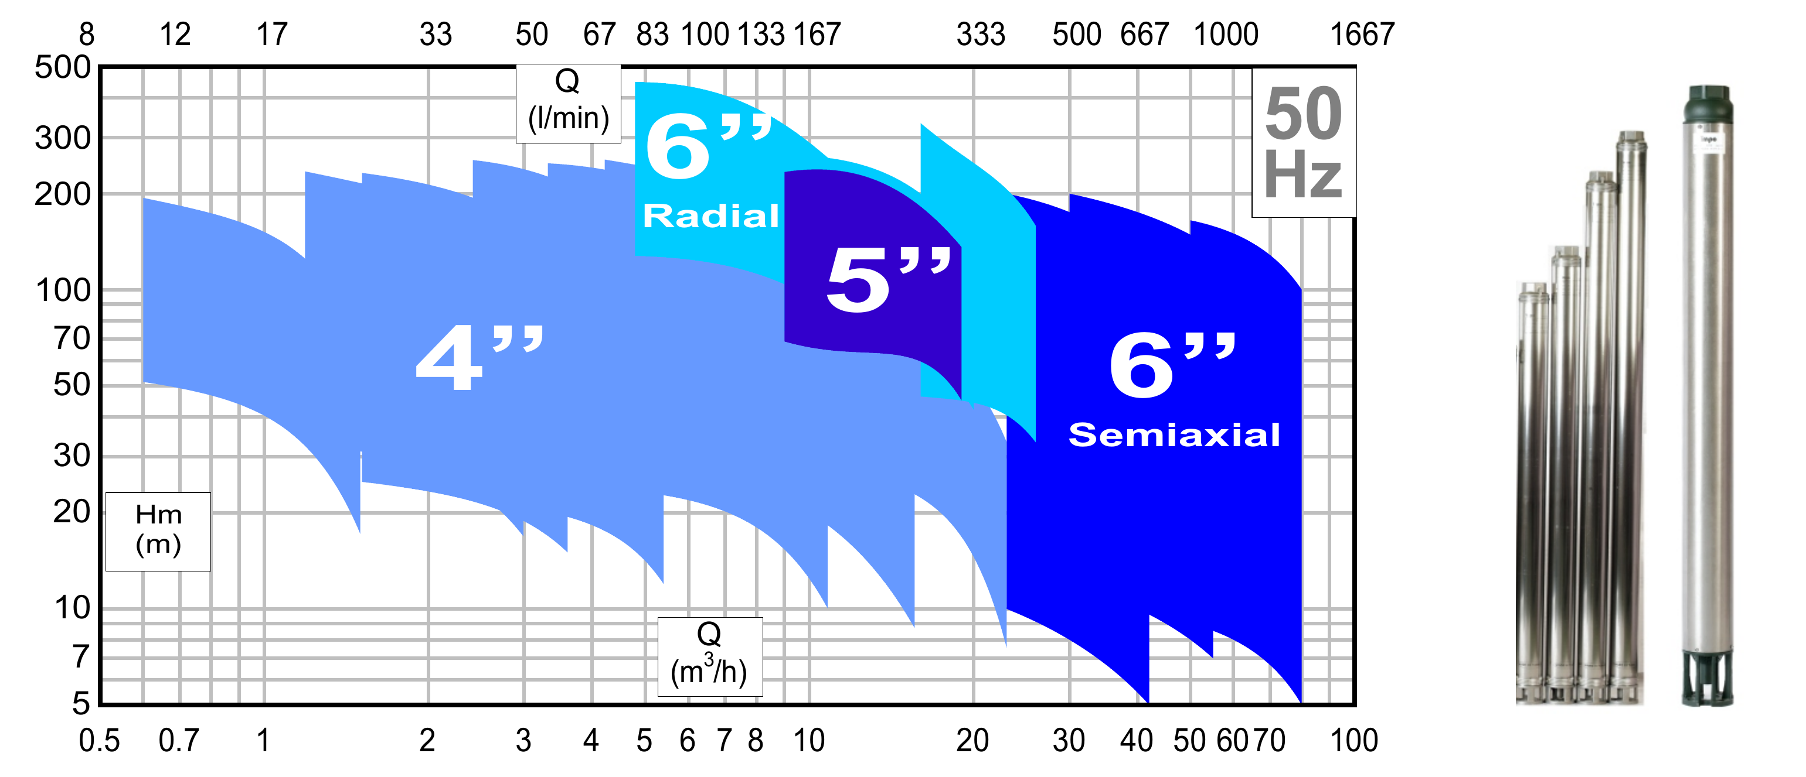

Cast Iron Pumps

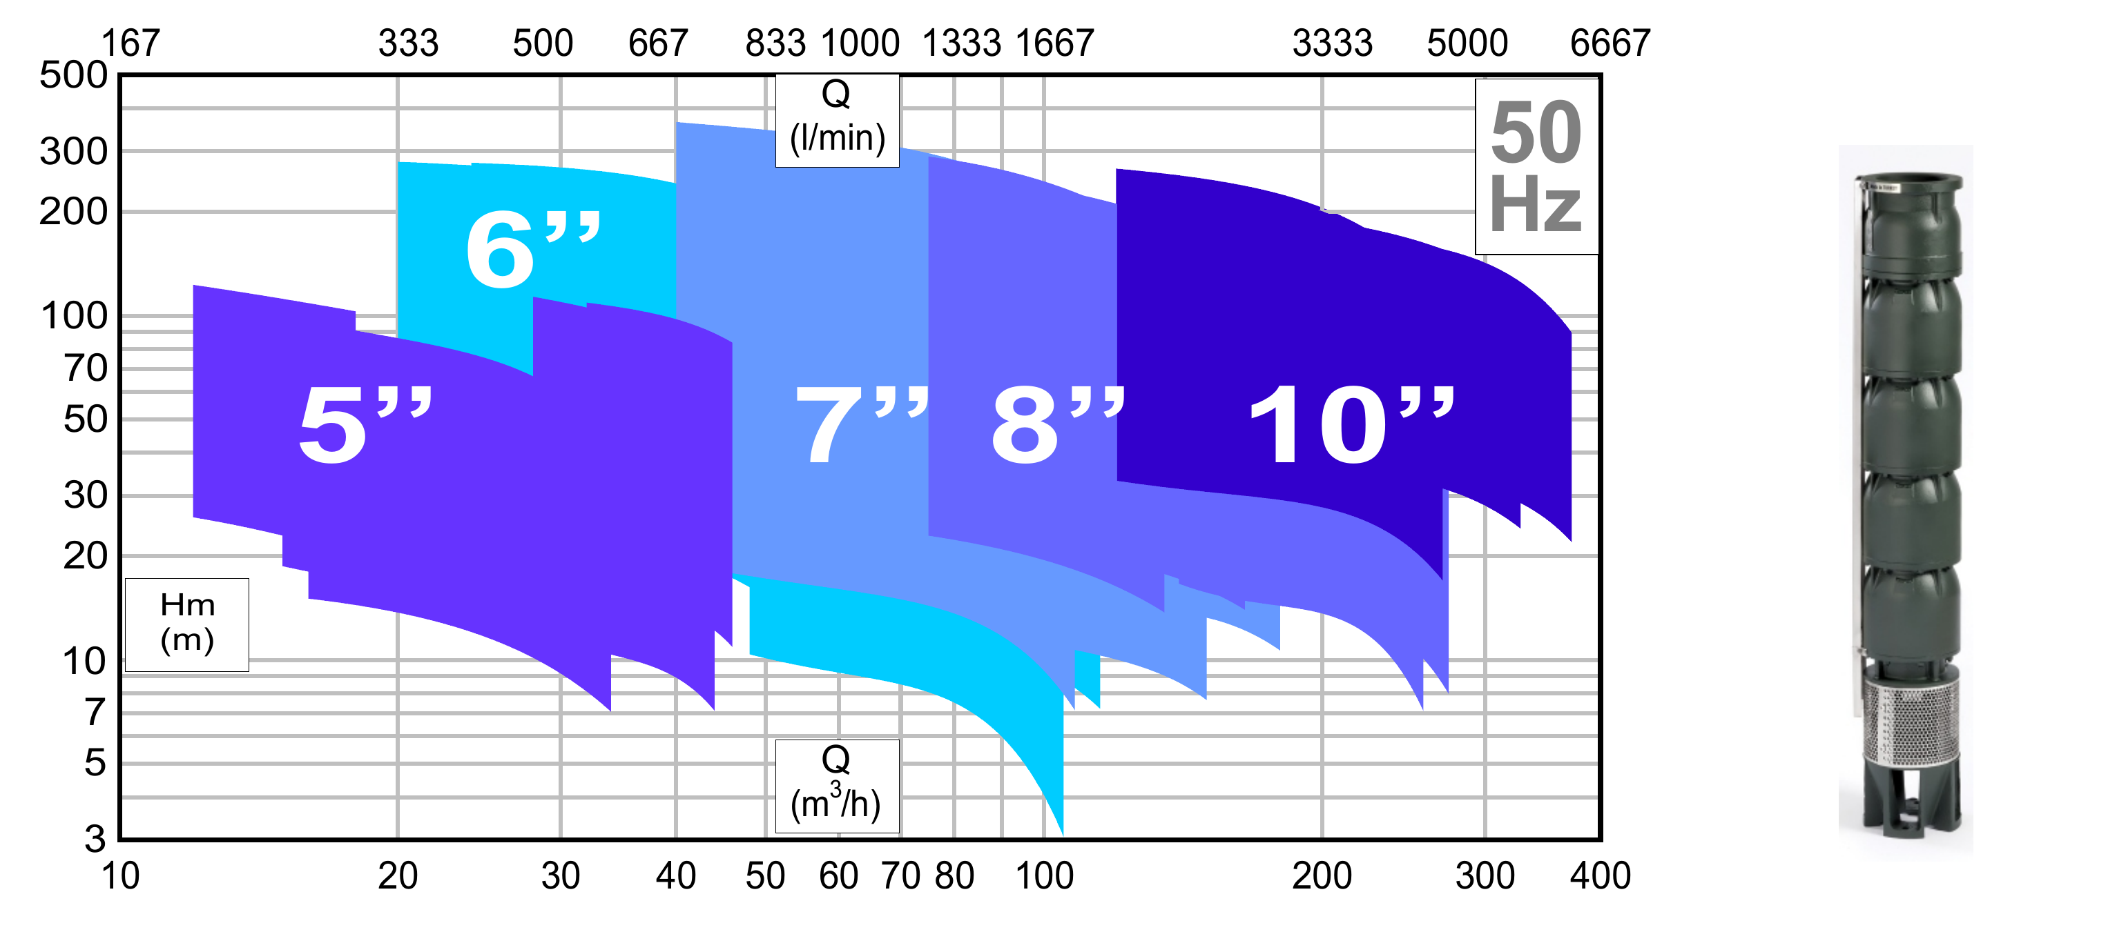

Stainless Steel Pumps
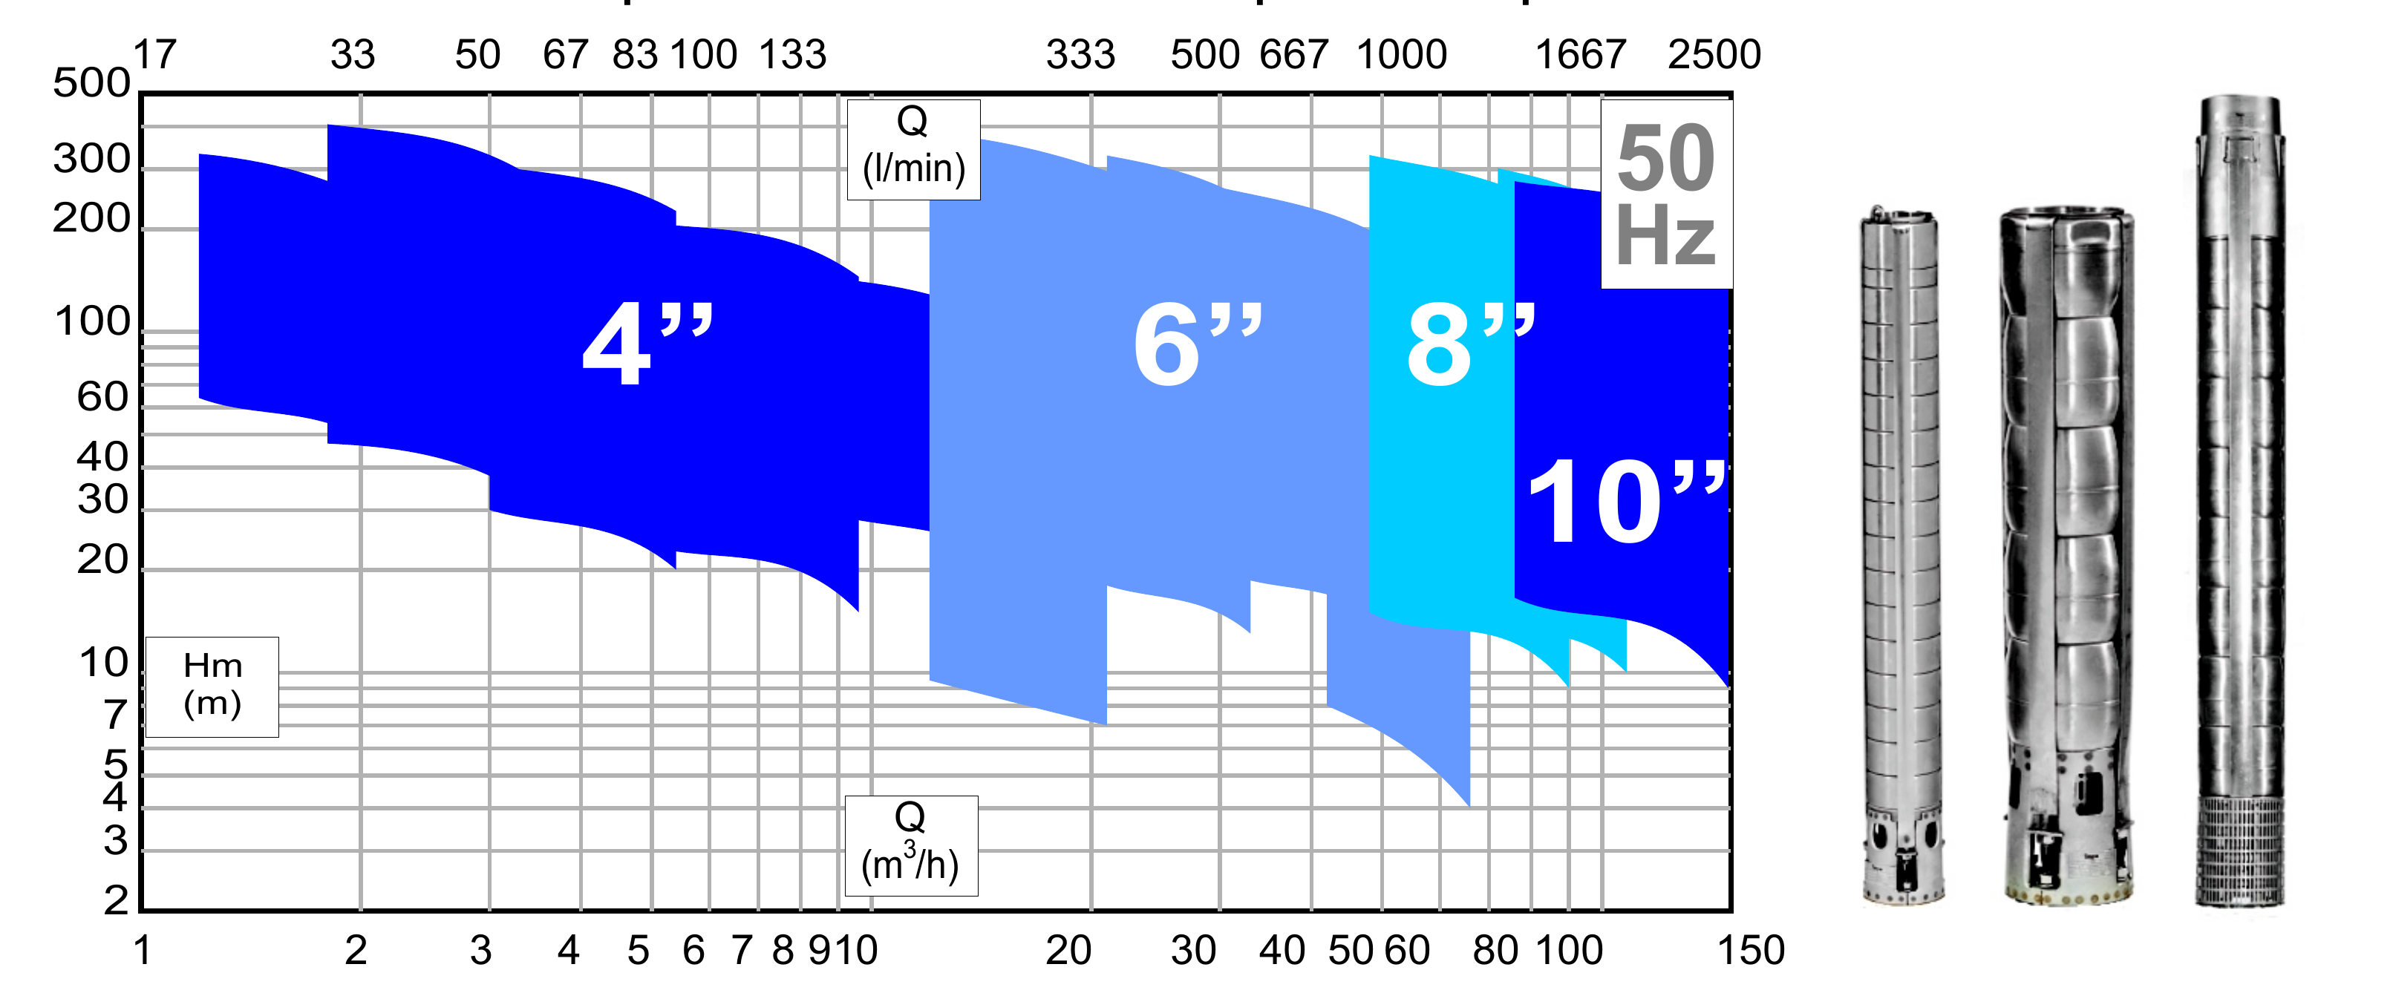

4 Inch Noryl Pumps
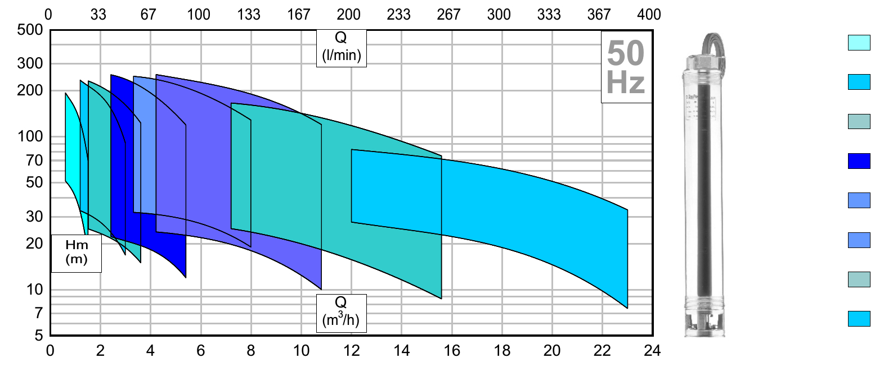
N-4-1
N-4-2
N-4-3
N-4-4
N-4-6
N-4-8
N-4-12
N-4-15

4 Inch Stainless Steel Pumps

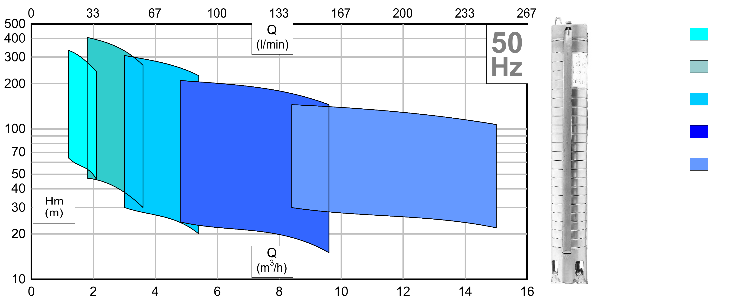
SS-4-2
SS-4-3
SS-4-4
SS-4-8
SS-4-12

5 Inch Cast Iron Pumps

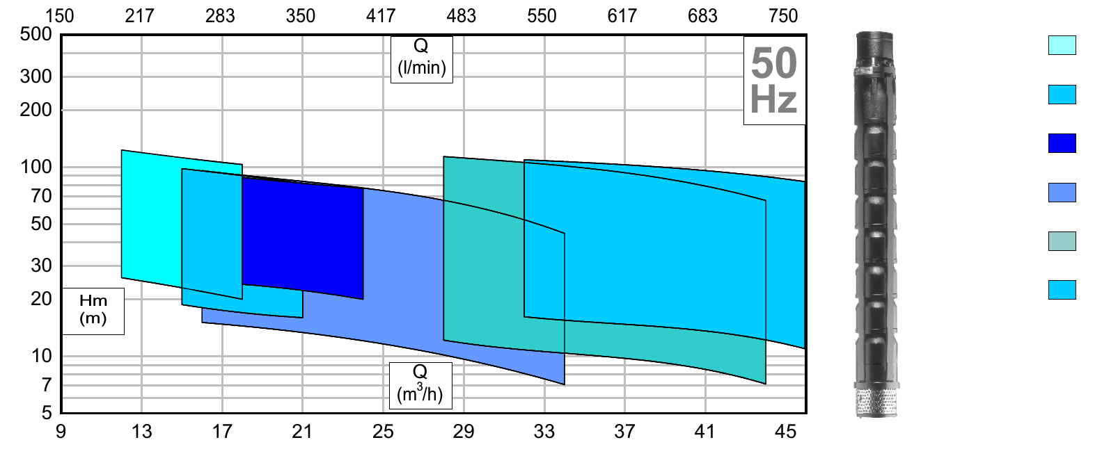
CI-5-18
CI-5-21
CI-5-24
CI-5-25
CI-5-35
CI-5-40

5 and 6 Inch Noryl Pumps

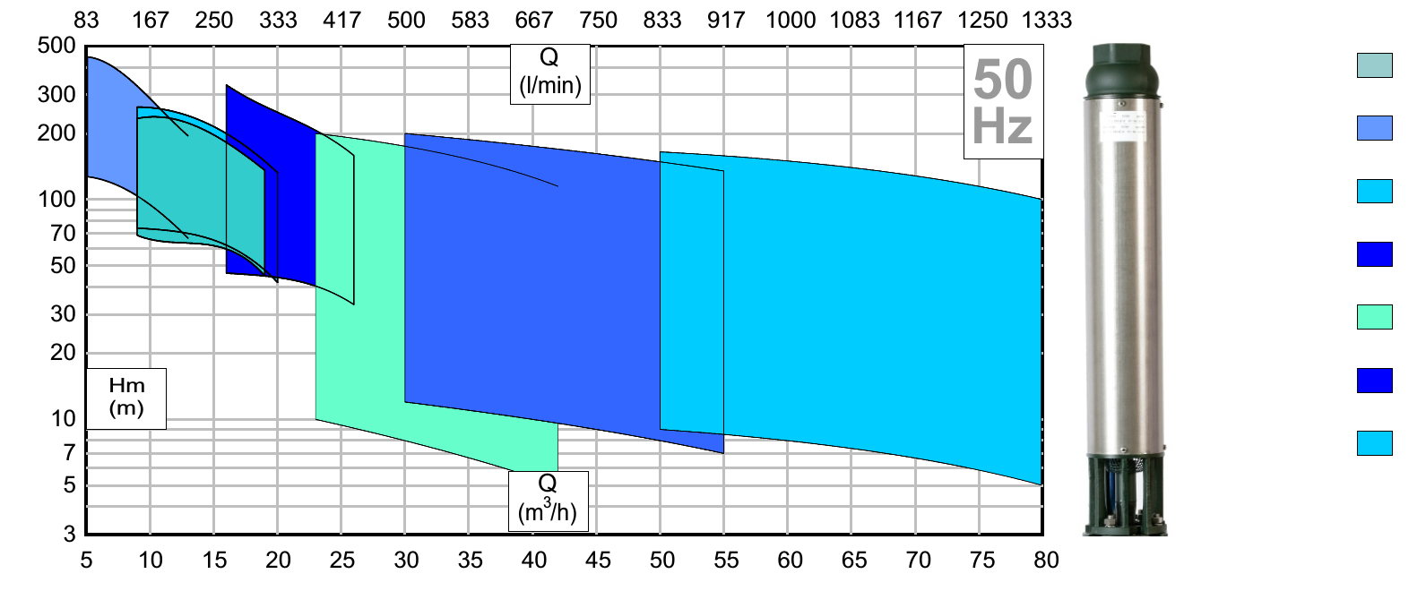
N-5-16
N-6-10
N-6-15
N-6-25
N-6-35
N-6-45
N-6-60

6 Inch Cast Iron Pumps

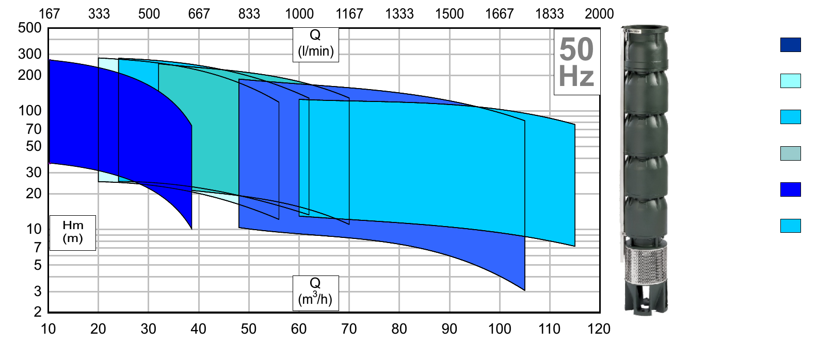
CI-6-30
CI-6-35
CI-6-45
CI-6-55
CI-6-75
CI-6-90

6 Inch Stainless Steel Pumps

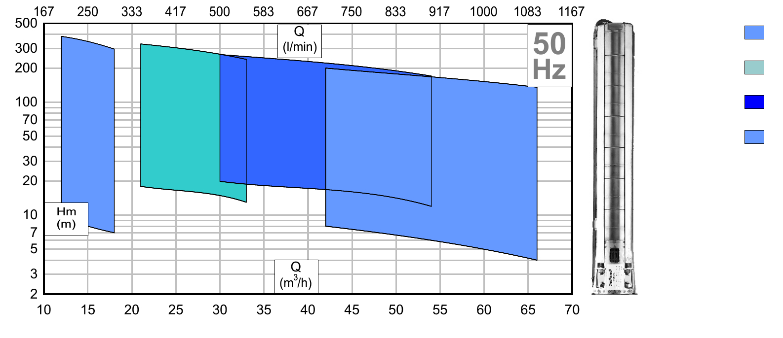
SS-6-15
SS-6-30
SS-6-42
SS-6-60

8 Inch Cast Iron Pumps

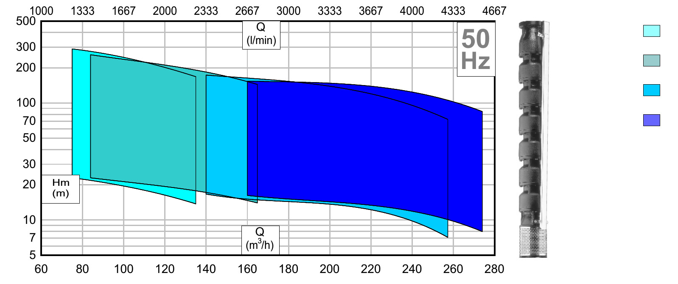
CI-8-9
CI-8-12
CI-8-18
CI-8-24

8 Inch Stainless Steel Pumps

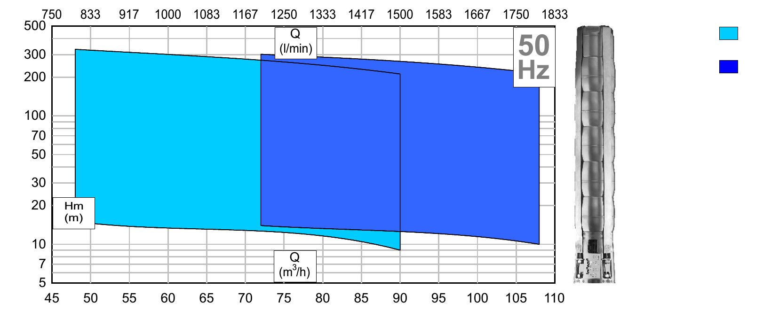
SS-8-72
SS-8-96

Noryl Material

The NORYL family of modified PPE resins consists of amorphous blends of PPO polyphenylene ether (PPE) resin and polystyrene. They combine the inherent benefits of PPE resin (affordable high heat resistance, good electrical insulation properties, excellent hydrolytic stability and the ability to use non-halogen fire retardant packages), with excellent dimensional stability, good processibility and low density.
Originally developed in 1966 by General Electric Plastics (now owned by SABIC). NORYL is a registered trademark of SABIC Innovative Plastics IP B.V.
NORYL resins are a rare example of a homogeneous mixture of two polymers. Most polymers are incompatible with one another, so tend to produce separate phases when mixed. The two polymers compatibility in NORYL resins is due to the presence of a benzene ring in the repeat units of both chains.
The addition of polystyrene to PPE increases the glass transition temperature above 100 °C, owing to the high Tg of PPE, so NORYL resin is stable in boiling water. The precise value of the transition depends on the exact composition of the grade used. There is a smooth linear relation between weight content of polystyrene and the Tg of the blend. Due to its good electrical resistance, it is widely used in switch boxes. However, product design is important in maximising the strength of the product, especially in eliminating sharp corners and other stress concentrations. Injection molding must ensure that moldings are stress-free.
Like most other amorphous thermoplastics, Noryl is sensitive to environmental stress cracking when in contact with many organic liquids. Compounds such as gasoline, kerosene, and methylene chloride may initiate brittle cracks resulting in product failure.
NORYL resins offer a good balance of mechanical and chemical properties, and may be suitable for a wide variety of applications such as in electronics, electrical equipment, coating, machinery, etc.
One of the most famous applications of NORYL was the molded case of the original Apple II computer. At that point, the product was referred to internally at Apple (1978) as "GE NORYL". A famous picture of an Apple II was made after a fire almost completely melted the NORYL case, but the motherboard, when removed from the case, was found to still operate.

NORYL resins have possible applications in the production of hydrogen, where it could serve as cost-effective electrodes in an electrolyzer, replacing expensive rare elements. It is highly resistant against the alkaline potassium hydroxide. For conductivity, the plastic is sprayed with a nickel-based catalyst.
NORYL resins are being investigated as a possible replacement for polycarbonate used in the manufacturing of Blu-ray Discs.
It is also used in certain construction products.

Noryl Corrosion Resistant Chemical-Resistance for Pumps
Chemical-resistant pump heads and impellers handle a variety of corrosive and caustic fluids over the entire pH range
- Chemical resistant pump heads and impellers handle a variety of corrosive and caustic fluids over the entire pH range
- Ideal for circulation, transfer, and chemical feed applications

Stainless Steel
In metallurgy, stainless steel, also known as inox steel or inox from French inoxydable (inoxidizable), is a steel alloy with a minimum of 10.5% chromium content by mass.
Stainless steel is notable for its corrosion resistance, and it is widely used for food handling and cutlery among many other applications.
Stainless steel is used for corrosion-resistant tools.
Stainless steel does not readily corrode, rust or stain with water as ordinary steel does. However, it is not fully stain-proof in low-oxygen, high-salinity, or poor air-circulation environments.
There are various grades and surface finishes of stainless steel to suit the environment the alloy must endure. Stainless steel is used where both the properties of steel and corrosion resistance are required.
Stainless steel differs from carbon steel by the amount of chromium present. Unprotected carbon steel rusts readily when exposed to air and moisture. This iron oxide film (the rust) is active and accelerates corrosion by making it easier for more iron oxide to form. Since iron oxide has lower density than steel, the film expands and tends to flake and fall away. In comparison, stainless steels contain sufficient chromium to undergo passivation, forming an inert film of chromium oxide on the surface. This layer prevents further corrosion by blocking oxygen diffusion to the steel surface and stops corrosion from spreading into the bulk of the metal. Passivation occurs only if the proportion of chromium is high enough and oxygen is present in it.
Stainless steel’s resistance to corrosion and staining, low maintenance, and familiar lustre make it an ideal material for many applications. The alloy is milled into coils, sheets, plates, bars, wire, and tubing to be used in cookware, cutlery, household hardware, surgical instruments, major appliances, industrial equipment (for example, in sugar refineries) and as an automotive and aerospace structural alloy and construction material in large buildings. Storage tanks and tankers used to transport orange juice and other food are often made of stainless steel, because of its corrosion resistance. This also influences its use in commercial kitchens and food processing plants, as it can be steam-cleaned and sterilized and does not need paint or other surface finishes.
If you are looking to eliminate the risk of corrosion in pumps and in turn reduce costly downtime, the answer is stainless steel.
With its excellent corrosion-resistant properties, stainless steel is by far the best choice for use in industrial applications either where high standards of hygiene are required or when the liquid pumped is troublesome.

We offer a wide ranges of stainless steel pumps.

In addition to its superior corrosion resistance, stainless steel provides a number of other benefits. Its hygienic, non-porous surface is easy to clean and the protective chromium oxide film prevents the pumped liquid from becoming contaminated with
undesirable particles. In addition to chromium, other elements such as nickel, molybdenum and nitrogen are added to give the steel special properties.

Cast Iron

Cast iron is a group of iron-carbon alloys with a carbon content greater than 2%. Its usefulness derives from its relatively low melting temperature. The alloy constituents affect its colour when fractured: white cast iron has carbide impurities which allow cracks to pass straight through, grey cast iron has graphite flakes which deflect a passing crack and initiate countless new cracks as the material breaks, and ductile cast iron has spherical graphite "nodules" which stop the crack from further progressing.
Carbon (C) ranging from 1.8–4 wt%, and silicon (Si) 1–3 wt% are the main alloying elements of cast iron. Iron alloys with lower carbon content (~0.8%) are known as steel. While this technically makes the Fe–C–Si system ternary, the principle of cast iron solidification can be understood from the simpler binary iron–carbon phase diagram. Since the compositions of most cast irons are around the eutectic point (lowest liquid point) of the iron–carbon system, the melting temperatures usually range from 1,150 to 1,200 °C (2,100 to 2,190 °F), which is about 300 °C (540 °F) lower than the melting point of pure iron.
Cast iron tends to be brittle, except for malleable cast irons. With its relatively low melting point, good fluidity, castability, excellent machinability, resistance to deformation and wear resistance, cast irons have become an engineering material with a wide range of applications and are used in pipes, machines and automotive industry parts, such as cylinder heads (declining usage), cylinder blocks and gearbox cases (declining usage). It is resistant to destruction and weakening by oxidation.
The earliest cast-iron artifacts date to the 5th century BC, and were discovered by archaeologists in what is now Jiangsu in China. Cast iron was used in ancient China for warfare, agriculture, and architecture. During the 15th century, cast iron became utilized for artillery in Burgundy, France, and in England during the Reformation. The first cast-iron bridge was built during the 1770s by Abraham Darby III, and is known as The Iron Bridge. Cast iron is also used in the construction of buildings.

Pump Material Selection Guide
http://www.waterworld.com/articles/print/volume-30/issue-12/inside-every-issue/pump-tips-techniques/the-impact-of-component-material-selection-on-pump-reliability.html
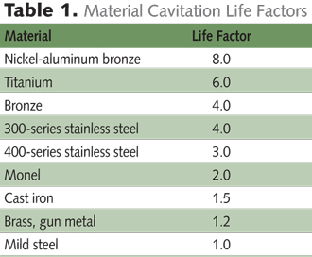

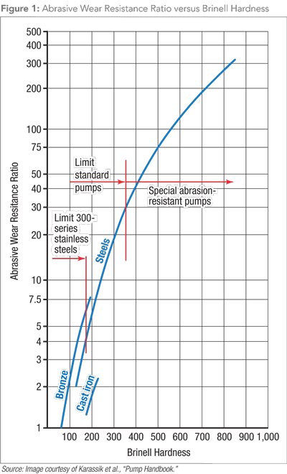

The following criteria should be considered in the selection of the material for a centrifugal pump impeller and/or casing:
- Corrosion resistance
- Abrasive-wear resistance
- Cavitation resistance
- Strength (primarily for the casings)
- Casting and machining properties
- Cost

Aluminum Pumps

ALUMINUM is a non-ferrous metal, very lightweight, approximately one-third as much as steel. Aluminum exhibits excellent atmospheric corrosion resistance, but can be very reactive with other metals.
Brass
The term used for alloys of copper and zinc in a solid solution is called brass. It is more than 50% copper and from 5 to 20% zinc. Brass comes with good strength. It has excellent high temperature ductility and reasonable cold ductility. Brass has also good conductivity and excellent corrosion resistance. Since it also has good bearing properties and low magnetic permeability, it is a ideal material for construction of pumps.
Bronze
Bronze is the term used for alloys of copper and tin. Sometimes, bronze is also found with other elements such as phosphorus, manganese, aluminum, or silicon. It is strong and tough, and has wide range of uses in industry. Bronze pumps are commonly specified for use on seawater, hot water and certain chemicals. Sintered bronze is a porous material, which can be impregnated with oil, graphite or PTFE. It is not suitable for heavily loaded applications but is of great use where lubrication is inconvenient.
Cast Iron Water Pumps
Cast Iron (normally close grained SG irons) are a popular choice for castings for general purpose pumps handling water, solvents and caustic solutions at low temperature. Impellers can be in cast iron or bronze. Cast grey iron is an alloy of iron, carbon and silicon; easily cast; good pressure tightness in the as-cast condition. Gray iron has excellent dampening properties and is easily machined. It is standard material for general purpose pumps. Gray iron has corrosion resistance that is better than steel in certain environments.
Cast Iron Bronze Fitted Pumps
Gray iron has excellent dampening properties and is easily machined. It is standard material for general purpose pump casings. Gray iron has corrosion resistance that is better than steel in certain environments. If the liquid handled is clean water with very little sand or silt, bronze generally offers the most cost effective solution. Bronze does not rust, is easy to cast and machine and generally offer superior surface finish of the waterways leading to efficiency gain.

Plastic Pumps
In plastic pumps all wetted parts are plastic material. Shaft, pedestals ans other non-wetted parts may be in metal or other appropriate material. Plastic pumps are designed to move fluids that would corrode or damage other types of pumps. They provide broad chemical resistance and are less costly and lighter in weight than metal pumps. Disadvantages of plastic pumps include limited pressure ratings, reduced impact resistance, and narrower temperature ranges. Some plastic pumps are designed to move abrasive materials, acids, adhesives, chemicals, coolants, hazardous materials, lubricants. Other devices are rated for combustible, corrosive, high viscosity, or high temperature media. Plastic pumps are also used to move gasoline, diesel fuel, and oil; ground water, potable water, salt water, and wastewater; sewage, sludge, slurry and ash slurry; gas and air; powders, solids, and rendering wastes; and a variety of liquids and liquids with solids.

Stainless Steel 304 Pumps
304 Stainless Steel is the standard "18/8" stainless; it is the most versatile and most widely used stainless steel, available in a wider range of products, forms and finishes than any other. The 304 stainless steel is the grade dominant in the manufacture of drawn stainless parts. It is not suitable for seawater
Stainless Steel 316 Pumps
316 STAINLESS STEEL is an alloy of iron, carbon, nickel, and chromium. A nonmagnetic stainless steel with more ductility than 304 SS. Austinetic in structure, 316 stainless steel has very good corrosion resistance to a wide range of environments, is not susceptible to stress corrosion cracking and is not affected by heat treatment. Suitable for sea water pumping

Nickle Plated
For most water and other noncorrosive services, bronze satisfies these criteria for the impeller and thus is the most widely used impeller material for these services. Cast iron impellers should generally be used to a limited extent in small, low-cost pumps. As cast iron is inferior to bronze in corrosion, erosion and cavitation resistance, low initial cost would be the only justification for a cast iron impeller. Further, stainless steel impellers are widely used where bronze would not satisfy the requirements for corrosion, erosion and/or cavitation resistance. For the pump casing, cast iron is the generally preferred material in most water and wastewater pumping applications.

Contact Information
http://atrc.net.pk/tawanai
Email : tawanai@atrc.net.pk
Phone : + 92 331 2036 422

