

Solar Pump Inverters
Tawanai Solar pumping systems contain the following :
DC Pumps, 3 Phase AC Motors
Large inverters for single Phase applications are available for unusual cases.
In some very specific cases, a single phase VFD might be available, but not for large power applications.
Solar Panels
Solar Pump Inverters
Features of solar pumping system
Wide MPPT range to improve the efficiency of the whole system. Efficiency is more than 99%.
Indoor and out door IP65 designs.
Full protection function can keep the system always in safe operation.
1 to 50 years warranties available with maintenance plans.
Build Operate and Transfer options.
Modular design, easy to install, operate and maintain.

Application areas including but not limited to :
Daily water using
Agricultural irrigation
Forestry irrigation
Desert control
Pasture animal husbandry
Rural town and village water supply
Desalinization of sea water
Scenic fountain
Factory
Residential wells

Technical Specifications for Solar Pump Inverters

Power Range: 1.1kw-110KW
MPPT Range:460~850VDC
Output Voltage: 220VAC or 380~460V AC; Three Phase Only
Output Frequency Range: 0~50/60Hz
Protection: IP65 for outdoor models

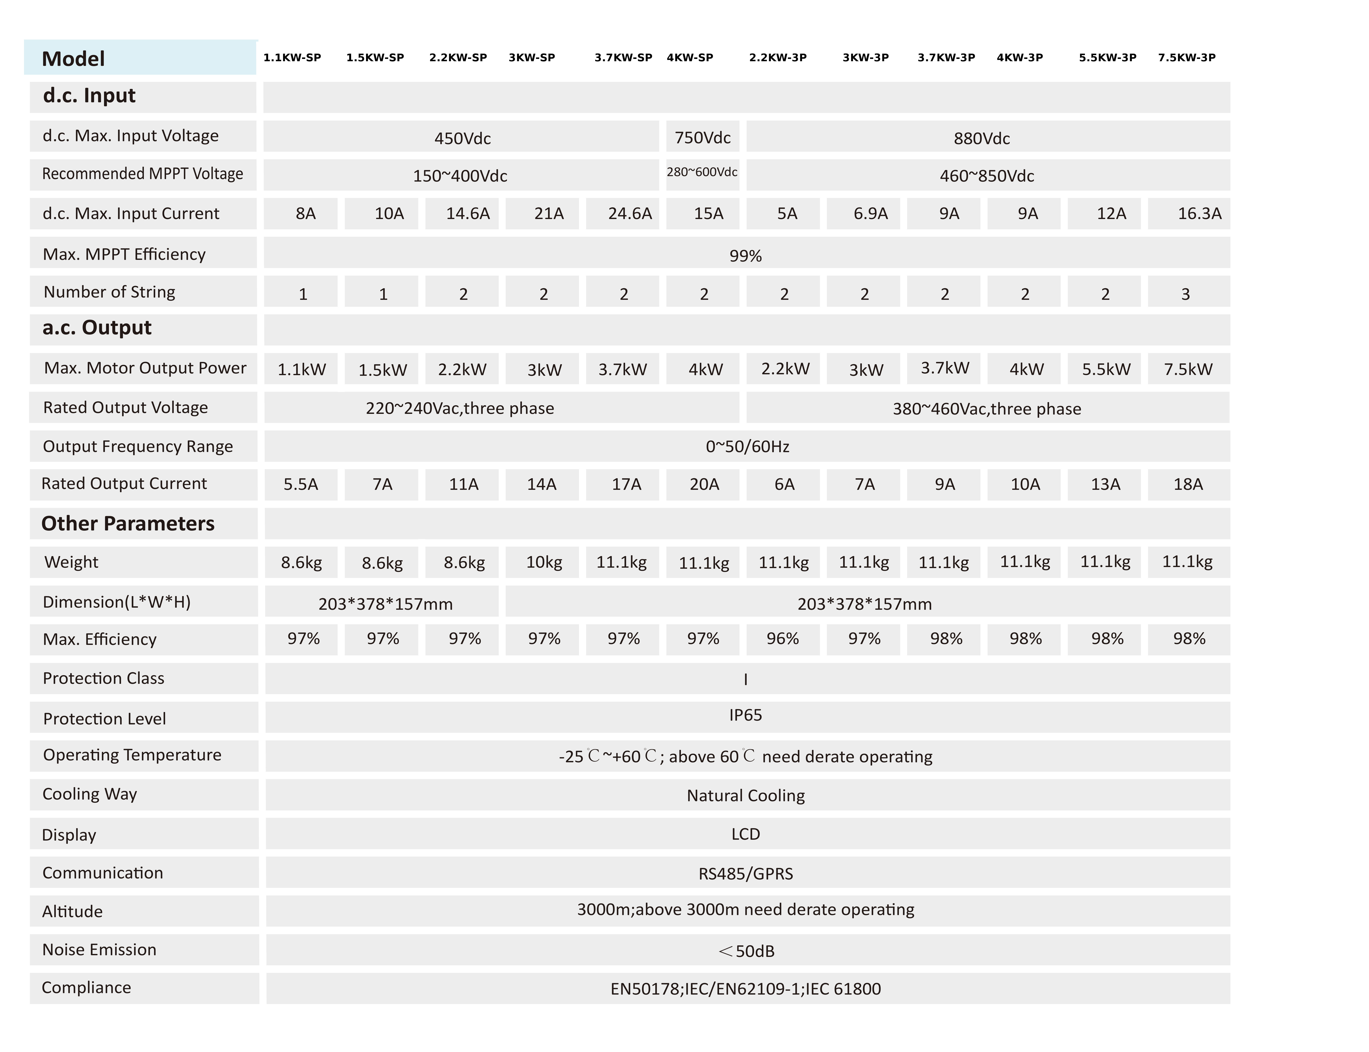
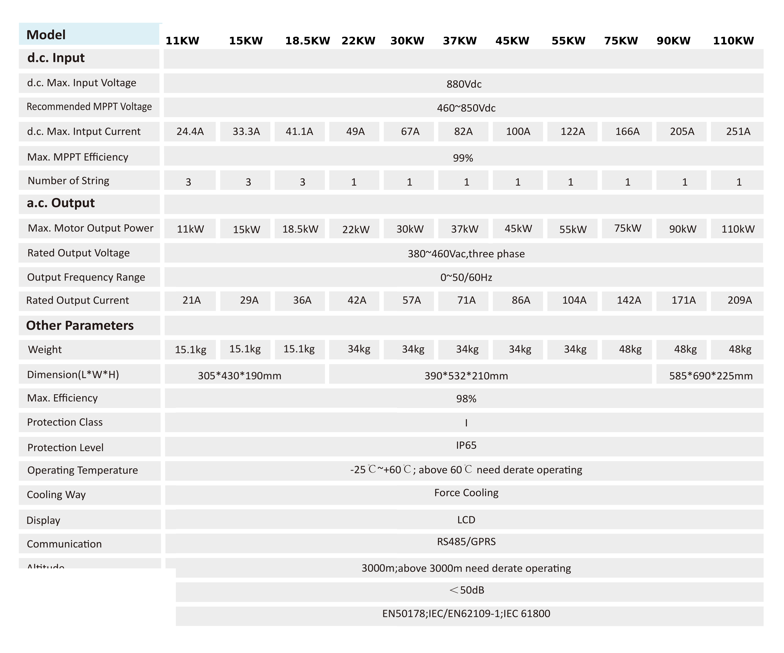

Contact :
http://atrc.net.pk/tawanai
Email : tawanai@atrc.net.pk
Phone : + 92 331 2036 422

