

Example calculation for pump requirement.
By : Khawar Nehal (khawar@atrc.net.pk)
Date : 30 January 2018

Customer requirement

Head: 140 ft
Flow: 1 Cusec
Efficiency: 100%
Power Absorb: 15.82kW
Motor Rating: 22kW

GPM to liters per minute conversion
Cusec to Liters per hour conversion

1 cusec = 101940.6492 Liters per hour = (about) 102 cubic meters per hour.
140 feet = 43 Meters.
List of 4 to 10 inches pumps commonly used.

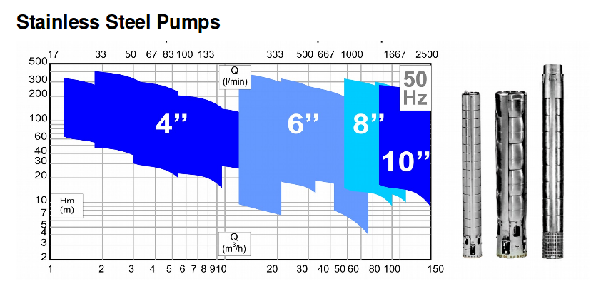
Looks like a 10 inch pump shall do the job.
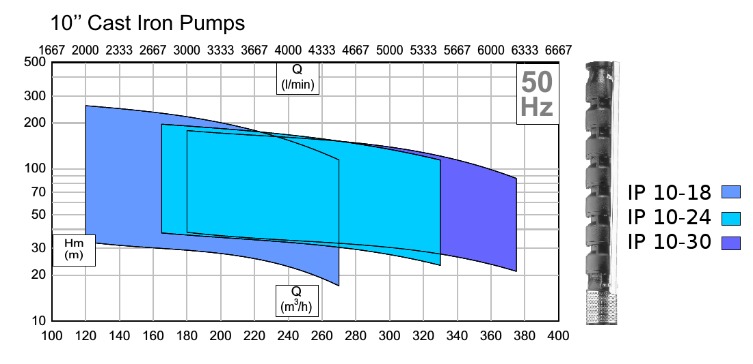
For 102,000 liters per hour at 43 meters we need the IP 10 – 18 - 2
Selected pump IP 10 – 18 - 2 with 60 HP 380V motor.
For 60 HP an 8 inch motor is available.
Need to confirm with suppliers the compatibility of the 8 inch motor with the 10 inch pump.
Rs 393,942
Price for this pump and motor.

