
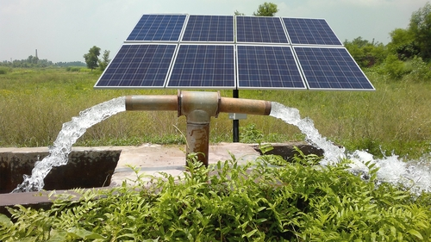

Date : 5 November 2017

Estimate for 20 HP solar pump, Solar power generator
Solar panels 15000 Watts
1 year paper warranty for all panels
18kw solar pump inverter.
Solar Panel Frames
DC circuit breakers refurbished
DC Fuses
Distribution box for breakers and fuses and DC combiner.
Total estimate including installation in Karachi : Rs 1.5 Million. (15 Lacs)

