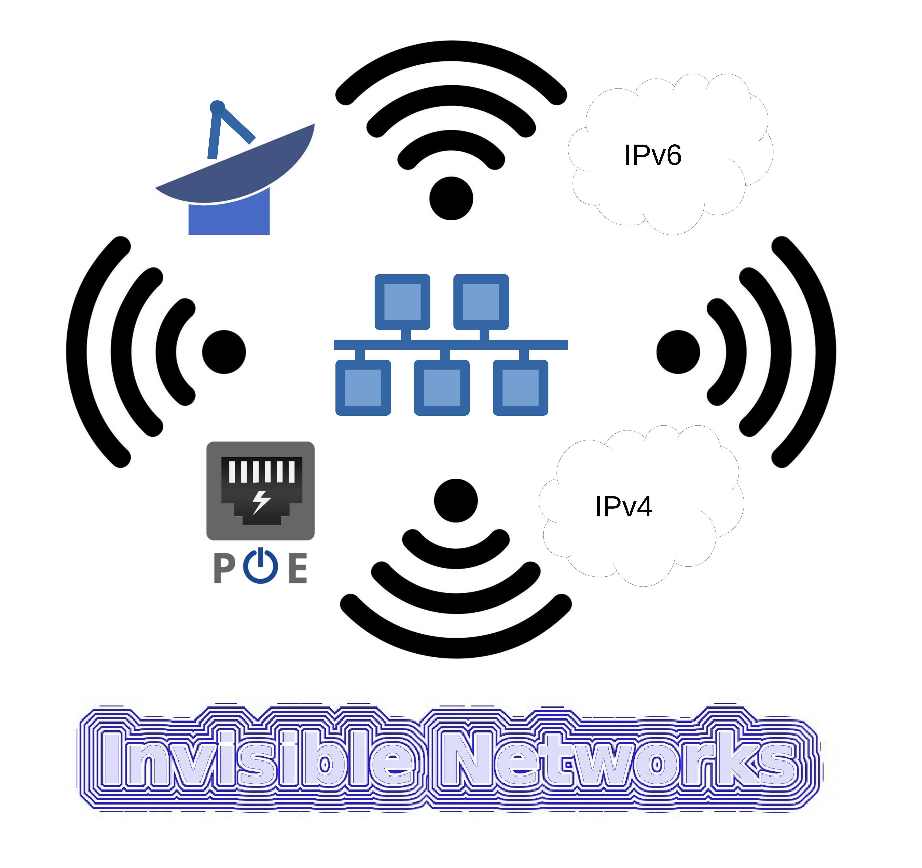

Join Our Innovative WiFi Server Project as a Cofounder or Team Member!
Are you passionate about technology and looking for an exciting opportunity to co-create a groundbreaking product? We invite you to join our dynamic team at ATRC as a cofounder or team member for our innovative WiFi server project. This is a unique chance to be part of a project that aims to revolutionize connectivity and network management.

About the Project
Our WiFi server project focuses on developing an advanced and efficient server solution designed to enhance wireless networking capabilities. This project aims to deliver robust performance, superior connectivity, and seamless management of WiFi networks, making it ideal for a wide range of applications.

Why Join Us?
- Equity Ownership: As a cofounder or team member, you will receive shares in the company, giving you a direct stake in our success.
- Innovative Environment: Work on cutting-edge technology and be part of a team that values creativity and innovation.
- Flexible Work Structure: Collaborate with a dedicated team remotely, allowing for a flexible working arrangement.

Open Positions
We are looking for talented individuals to fill the following roles:

1. Software Developer
- Responsibilities: Develop and maintain software components for the WiFi server, implement new features, and ensure optimal performance.
- Requirements: Proficiency in programming languages such as Bash, Pascal, Go, Python, C, CPP; experience with network protocols and server architecture.

2. Network Engineer
- Responsibilities: Design, configure, and optimize network infrastructure; ensure the stability and scalability of the WiFi server.
- Requirements: In-depth knowledge of networking principles, experience with WiFi technology, and expertise in network security.

3. UI/UX Designer
- Responsibilities: Create intuitive and user-friendly interfaces for the WiFi server management console, enhance user experience.
- Requirements: Strong design skills, proficiency in design tools (e.g., Adobe XD, Figma), and a portfolio showcasing previous UI/UX work.

4. Product Manager
- Responsibilities: Oversee the development process, define product vision and strategy, and ensure alignment with market needs.
- Requirements: Excellent project management skills, experience in product development, and a strategic mindset.

Who We’re Looking For
- Entrepreneurial Spirit: Individuals who are passionate about startups and willing to take risks for potential high rewards.
- Team Players: Collaborative and communicative individuals who thrive in a team-oriented environment.
- Innovators: Creative thinkers who can contribute new ideas and solutions to the project.

Compensation
This is an equity-only position. You will be compensated with shares in the company, aligning your success directly with the success of the project.

How to Apply
If you're excited about this opportunity and believe you have the skills and passion to contribute to our WiFi server project, we'd love to hear from you! Please send your resume and a brief cover letter explaining why you're interested in joining our team to khawar@remote-support.space
Join us in shaping the future of wireless networking. Together, we can make a significant impact!
Project URL : https://atrc.net.pk/dokuwiki/doku.php?id=products:ict:wifi-server

