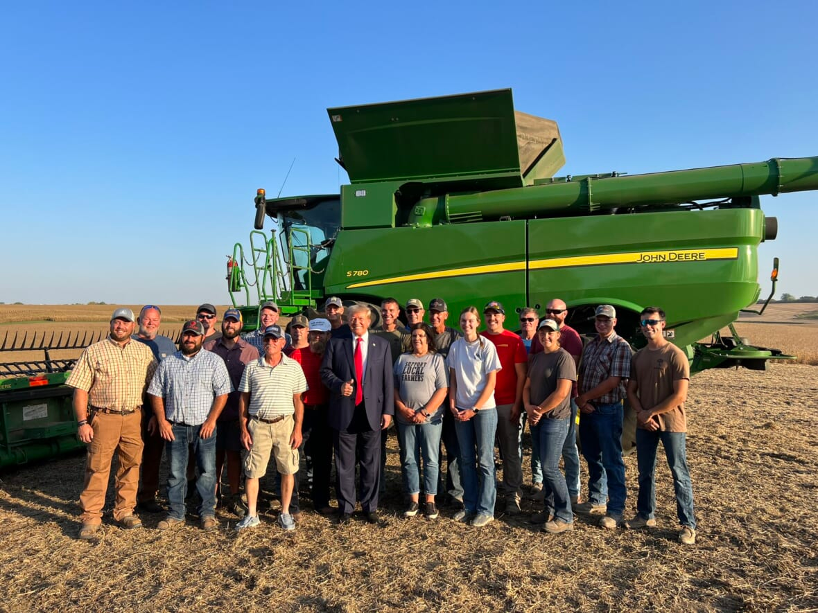
The virtual wall and other things which most choose to ignore about Mr. Trump.
Explanation via the quotes of others.
If you are doing something right then a lot of people shall resist your actions.
Martin Luther King Jr. said:
"Injustice anywhere is a threat to justice everywhere."
Mahatma Gandhi said :
"First they ignore you, then they laugh at you, then they fight you, then you win."
Steven Pressfield said :
“We can never eliminate Resistance. It will never go away. But we can outsmart it, and we can enlist allies that are as powerful as it is,”
Robert Frost said :
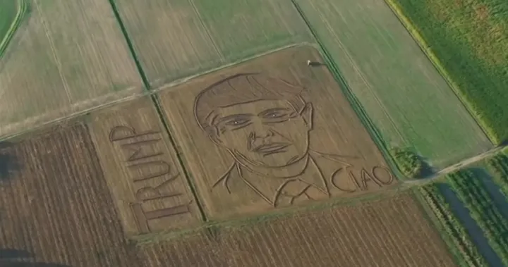
"The best way out is always through,"
Maya Lin said :
“To fly, we have to have resistance,”
Ralph Waldo Emerson said :
“For every action, there is a reaction,”
Winston Churchill: Said :
"You have enemies? Good. That means you’ve stood up for something, sometime in your life"
The "virtual wall," as envisioned during Donald Trump's presidency, involved enhancing border security through technological solutions, increased surveillance, and data analytics rather than solely relying on a physical barrier. Several factors contributed to increases in visa application fees and revenues during that time. Here’s how the virtual wall indirectly influenced visa revenues from Mexican nationals:

1. Increased Visa Fees
- Fee Adjustments: The Trump administration proposed increasing visa application fees for various visa categories, including those commonly used by Mexican nationals (e.g., tourist visas, work visas). These increased fees were intended to generate additional revenue for the government and border security measures.
- Higher Revenues: As more Mexican nationals applied for visas, the increased fees directly contributed to higher visa revenues. Even with a more rigorous application process, demand for U.S. visas among Mexicans remained strong, leading to a potential boost in overall revenue.

2. Focus on Enforcement and Compliance
- Emphasis on Legal Immigration: The virtual wall concept was part of a broader strategy to enhance legal immigration pathways while cracking down on illegal immigration. This focus encouraged more Mexicans to apply for visas to ensure legal entry into the U.S.
- Increased Trust in the System: Improved border security and enforcement measures might have increased trust in the legal immigration process, encouraging more individuals to pursue visas rather than attempting illegal crossings. This shift would result in increased visa applications and revenues.

3. Streamlined Processes and Technology
- Use of Technology: The integration of technology in visa processing (e.g., biometric data and advanced data analytics) aimed to improve efficiency and security. This resulted in faster processing times, making it more appealing for Mexican nationals to apply for visas.
- Greater Convenience: With more streamlined processes, potential applicants may have been more likely to pursue U.S. visas, thereby increasing the volume of applications and associated revenues.

4. Increased Border Security and Deterrence of Illegal Crossings
- Discouraging Unauthorized Immigration: The emphasis on a virtual wall and enhanced border security deterred unauthorized crossings, pushing more individuals to seek legal entry through visas. This shift would lead to an increase in the number of applications and fees collected.
- Visa as a Safer Option: With heightened border enforcement, many individuals may have perceived obtaining a visa as a safer and more reliable means of entering the U.S., thereby driving up demand for legal entry channels.

5. Demand for Temporary and Work Visas
- Labor Needs: The U.S. economy's ongoing demand for labor, particularly in industries like agriculture, construction, and services, led to an increased demand for temporary work visas (H-2A and H-2B). This demand resulted in more Mexican nationals applying for these visas, thereby boosting revenue from visa fees.
- Visitor Visas: The continued appeal of the U.S. as a travel destination for Mexican tourists also meant consistent demand for visitor visas (B1/B2), contributing to increased revenues even amid stricter regulations.
While the concept of a "virtual wall" primarily focused on technological solutions and border security, several factors associated with this approach contributed to increased visa revenues from Mexican nationals. The combination of increased visa fees, a greater emphasis on legal immigration, streamlined processes, and changing perceptions around border security all played a role in encouraging more applicants to pursue visas, thereby boosting revenue for the U.S. government.

Economy and Jobs
- Tax Cuts and Jobs Act (2017): Reduced corporate tax rates and aimed to stimulate economic growth.
- Record Low Unemployment: Achieved historically low unemployment rates, particularly for African Americans and Hispanics.
- Deregulation: Rolled back numerous regulations aimed at promoting business growth and reducing compliance burdens.
- Job Creation: The economy added millions of jobs during his term before the COVID-19 pandemic.
- NAFTA Replacement (USMCA): Negotiated a new trade agreement with Canada and Mexico to replace NAFTA, aiming to benefit American workers.

Trade and Foreign Policy
- Tariffs on China: Imposed tariffs on Chinese goods to address trade imbalances and intellectual property theft.
- Middle East Peace Efforts: Facilitated the Abraham Accords, normalizing relations between Israel and several Arab nations.
- Recognition of Jerusalem: Recognized Jerusalem as the capital of Israel, moving the U.S. embassy there.
- Withdrawal from the Iran Deal: Exited the Joint Comprehensive Plan of Action (JCPOA) to take a harder stance on Iran.
- Support for NATO: Encouraged NATO allies to increase their defense spending.

Immigration and Border Security
- Increased Border Security: Enhanced border security measures and funding for border patrol.
- Travel Ban: Implemented a travel ban from several countries deemed security risks, which supporters argued enhanced national security.
- Asylum Policy Changes: Enacted policies aimed at reducing asylum claims and streamlining the process.
- End of Catch-and-Release: Eliminated the practice of releasing migrants into the U.S. while awaiting immigration hearings.
- DACA Negotiations: Attempted to negotiate a deal for Dreamers, aiming to find a legislative solution.

Healthcare
- Prescription Drug Reform: Advocated for measures to lower prescription drug prices.
- Expansion of Telehealth: Promoted telehealth services, especially during the COVID-19 pandemic.
- Affordable Care Act (ACA) Repeal Efforts: Continued efforts to repeal and replace the ACA.

Criminal Justice and Law Enforcement
- First Step Act: Passed criminal justice reform aimed at reducing recidivism and addressing sentencing disparities.
- Support for Law Enforcement: Advocated for funding and support for police and law enforcement agencies.

National Security
- Strengthened Military: Increased defense spending and prioritized military modernization.
- ISIS Defeat: Oversaw military operations that significantly weakened ISIS in Iraq and Syria.
- Strategic National Defense: Focused on addressing threats from China and Russia.

Infrastructure and Energy
- Infrastructure Initiatives: Launched initiatives to improve U.S. infrastructure, although some faced challenges in implementation.
- Energy Independence: Promoted policies that contributed to U.S. energy independence, including increased domestic oil and gas production.
- Keystone XL Pipeline: Approved the Keystone XL and Dakota Access pipelines to boost energy infrastructure.

Environment and Conservation
- Withdrawal from the Paris Agreement: Argued that it was not in the best interest of the U.S. economy.
- Conservation Efforts: Signed legislation to promote conservation and improve access to national parks.

Education and Workforce Development
- Support for School Choice: Advocated for school choice initiatives and charter schools.
- Apprenticeship Programs: Promoted vocational training and apprenticeship programs to address workforce needs.

Economic Recovery
- COVID-19 Economic Relief: Implemented the CARES Act, providing economic relief to businesses and individuals during the pandemic.
- PPP Loans: Established the Paycheck Protection Program to support small businesses and protect jobs.

International Relations
- Direct Diplomacy with North Korea: Engaged in historic summits with North Korean leader Kim Jong-un.
- Strengthened Ties with Israel: Deepened U.S.-Israel relations beyond just diplomatic recognition.

Social Issues
- Judicial Appointments: Appointed three Supreme Court justices and numerous federal judges, influencing the judiciary for years to come.
- Religious Freedom Advocacy: Promoted policies supporting religious freedom and the rights of religious organizations.

Technology and Innovation
- Space Force Creation: Established the U.S. Space Force as a new branch of the military.
- Promotion of 5G Technology: Advocated for the rollout of 5G technology to improve U.S. technological competitiveness.

Foreign Aid and Humanitarian Efforts
- Support for Israel: Increased financial support for Israel's defense capabilities.
- Aid to Central America: Provided aid aimed at addressing the root causes of migration from Central American countries.

Governance and Administration
- Reduction of Federal Workforce: Reduced the size of the federal workforce through attrition.
- Focus on Accountability: Promoted policies aimed at increasing government accountability and reducing waste.

Public Safety and Civil Rights
- Support for Second Amendment Rights: Advocated for gun rights and opposed gun control measures.
- Judicial Support for Religious Freedom: Nominated judges supportive of religious liberties.

Miscellaneous
- Promotion of American Manufacturing: Advocated for policies aimed at bringing manufacturing jobs back to the U.S.
- Fostering Nationalism: Promoted "America First" policies, emphasizing national interests in trade and foreign affairs.
- Investment in Opioid Crisis Response: Allocated funds to combat the opioid crisis through treatment and prevention efforts.
- Civic Engagement Initiatives: Encouraged civic engagement through initiatives aimed at improving voter participation and education.
- Financial Market Growth: Witnessed significant growth in the stock market during much of his presidency.
- Historical Criminal Justice Reform: Highlighted efforts to address systemic issues within the criminal justice system.

For rural areas these were some of the benefits.

- Rural Infrastructure Program: Trump's administration allocated $50 billion of a proposed $200 billion infrastructure plan specifically for rural areas. This funding was designed to rebuild and modernize infrastructure, including roads and community facilities, giving states the flexibility to prioritize projects based on local needs.

- Broadband Expansion: Under the USDA’s ReConnect Broadband Program, significant investments were made to expand broadband access in rural communities, helping to bridge the digital divide and improve educational and health service access. The USDA committed over $200 million to enhance broadband infrastructure in rural areas.

- Community Facilities Program: This program provided loans, grants, and loan guarantees to develop essential public services and facilities in rural communities. It was crucial for upgrading infrastructure that had often been neglected
- Environmental Reviews and Permitting: Trump signed an executive order aimed at streamlining the environmental review process, which had historically delayed infrastructure projects. The goal was to expedite the approval process for major projects to ensure timely improvements

- Investment in Roads and Bridges: His administration emphasized the need to repair and upgrade rural roads and bridges, many of which had been in poor condition for decades. This included addressing the significant number of bridges over 50 years old

- Job Creation and Economic Development: The investments in infrastructure were expected to create jobs and stimulate economic development in rural areas, improving the overall quality of life for residents

These initiatives represent a focused effort to address the infrastructure deficits in rural America, which had often been overlooked in previous decades.
So next time you see a lot of people talking bad against a popular person, do slow down to see the other side of the story. Maybe the reason they are blabbing is because the person might be doing something right.

