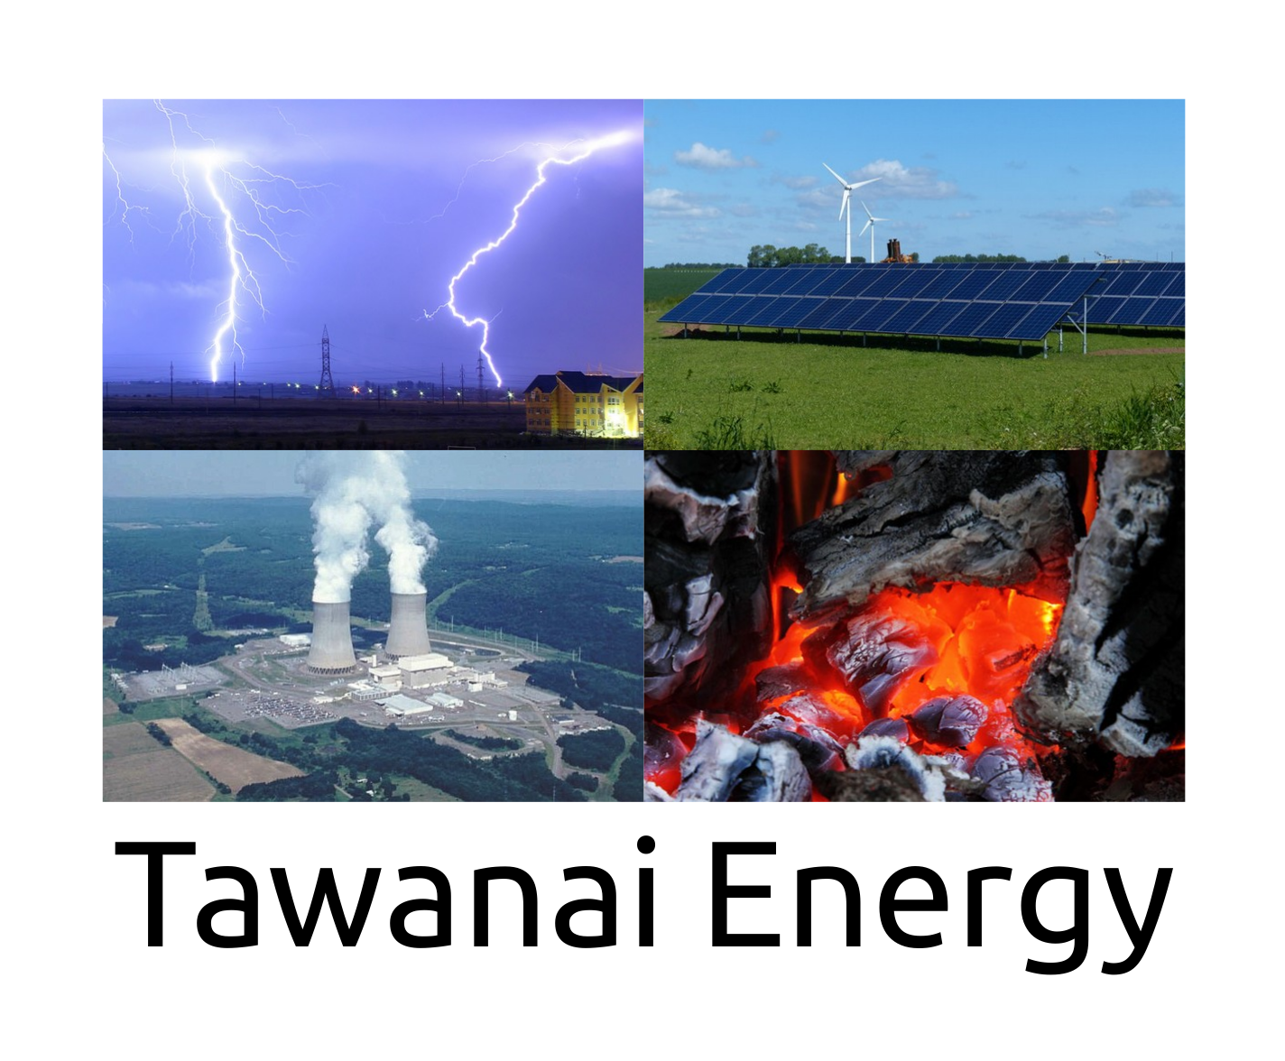
Some of the solutions available.

Solar powered water pumping

Residential Solar Power

Battery solutions for storing excess energy

Netmetering with battery option

Specially designed energy system based on specific requirements

Why buy solutions from us

Contact information

Solar powered water pumping

Benefits :
Return on investment within 1.5 years when compared to diesel power.
Basically free power after 1.5 years.
No more rewiring of motor windings due to electrical power quality.
Average life of motor winding is 10 years.
Solar power is pollution free.
Reduced dependence on foreign oil and fossil fuels
Renewable clean power that is available every day of the year, even cloudy days produce some power
Virtually no maintenance as solar panels last over 50 years
Frames need to be painted every year if they are made of corroding materials.
Can be installed virtually anywhere near the pump.
Can be installed in a central location and power can be distributed to various pumping sites. This is a special design available from Tawanai.

Residential Solar

Benefits :
Return on investment within 7 years when compared to utility power.
Backup power available when utility power fails.
Basically free power after 7 years.
Solar power is pollution free.
Reduced dependence on utility power.
Netmetering is optional to send extra electricity to the grid.
Renewable clean power that is available every day of the year, even cloudy days produce some power
Virtually no maintenance as solar panels last over 50 years
Galvanized steel frames can last up to 10 years without corroding. Longer if maintained well.

Why buy solutions from us :

We have been developing energy systems for ICT, Internet Services and Telecom related services since the 1990s. We also researched all of the different types of energy generation methods for more than 20 years before we stated offering solutions.

- We use reliable suppliers and know of thousands directly and hundreds of thousands for specialist work. With over 20 years of experience in evaluating suppliers for products, services and parts.
- Selection from the best technology and suppliers available at the time for your specific requirement.
- We know and track new developments in technologies for 10 to 20 years before being able to recommend the final products to our customers. It takes a long time for an idea to become a product or service or a part of a system.
- Courteous, knowledgeable and professional support
- Lots of satisfied customers

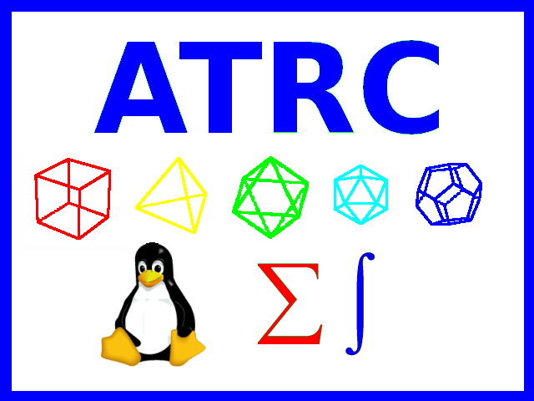
Contact :

Mr. Khawar Nehal
Email : khawar@atrc.net.pk
Mobile :
Ufone : +92 331 2036 422
Telenor : +92 343 2702 932
Zong : +92 316 0297 564
Warid/Mobilink/Jazz : +92 309 2604 780

 khawar.nehal


http://atrc.net.pk/contact/contact.html

http://atrc.net.pk/




