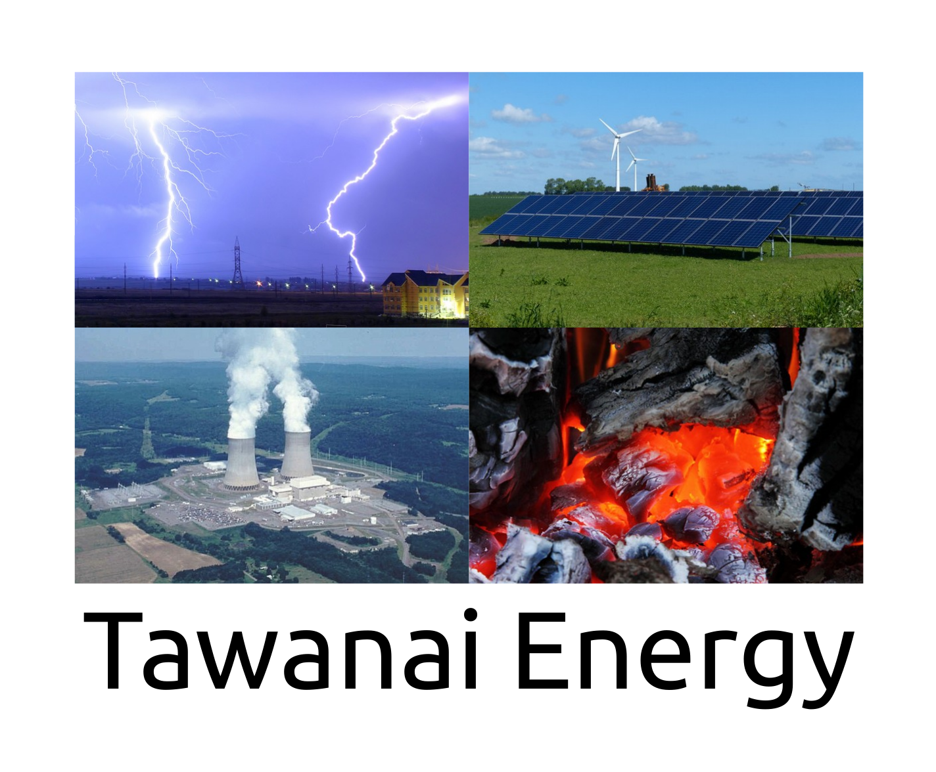

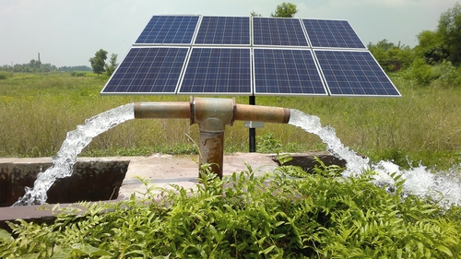

Feasibility Studies

- Location analysis
- Shade Study
- Power Transmission Analysis
- Financial Analysis
Engineering Design

- Solar module selection
- Component Selection
- Monitoring and Communication System Design
- Power Grid Transmission Design
Installation

- Site Preparation
- Component Installation and Wiring
- Inspection by Grid Operator and Commissioning.
Project Design

- System Configuration
- Technical Cost Benefit Analysis
- Budgetary Estimates
- Power Output Analysis
- Return on Investment Analysis
Our professional team of engineers have experience in designing and installing solar power systems.


Email : tawanai@atrc.net.pk

