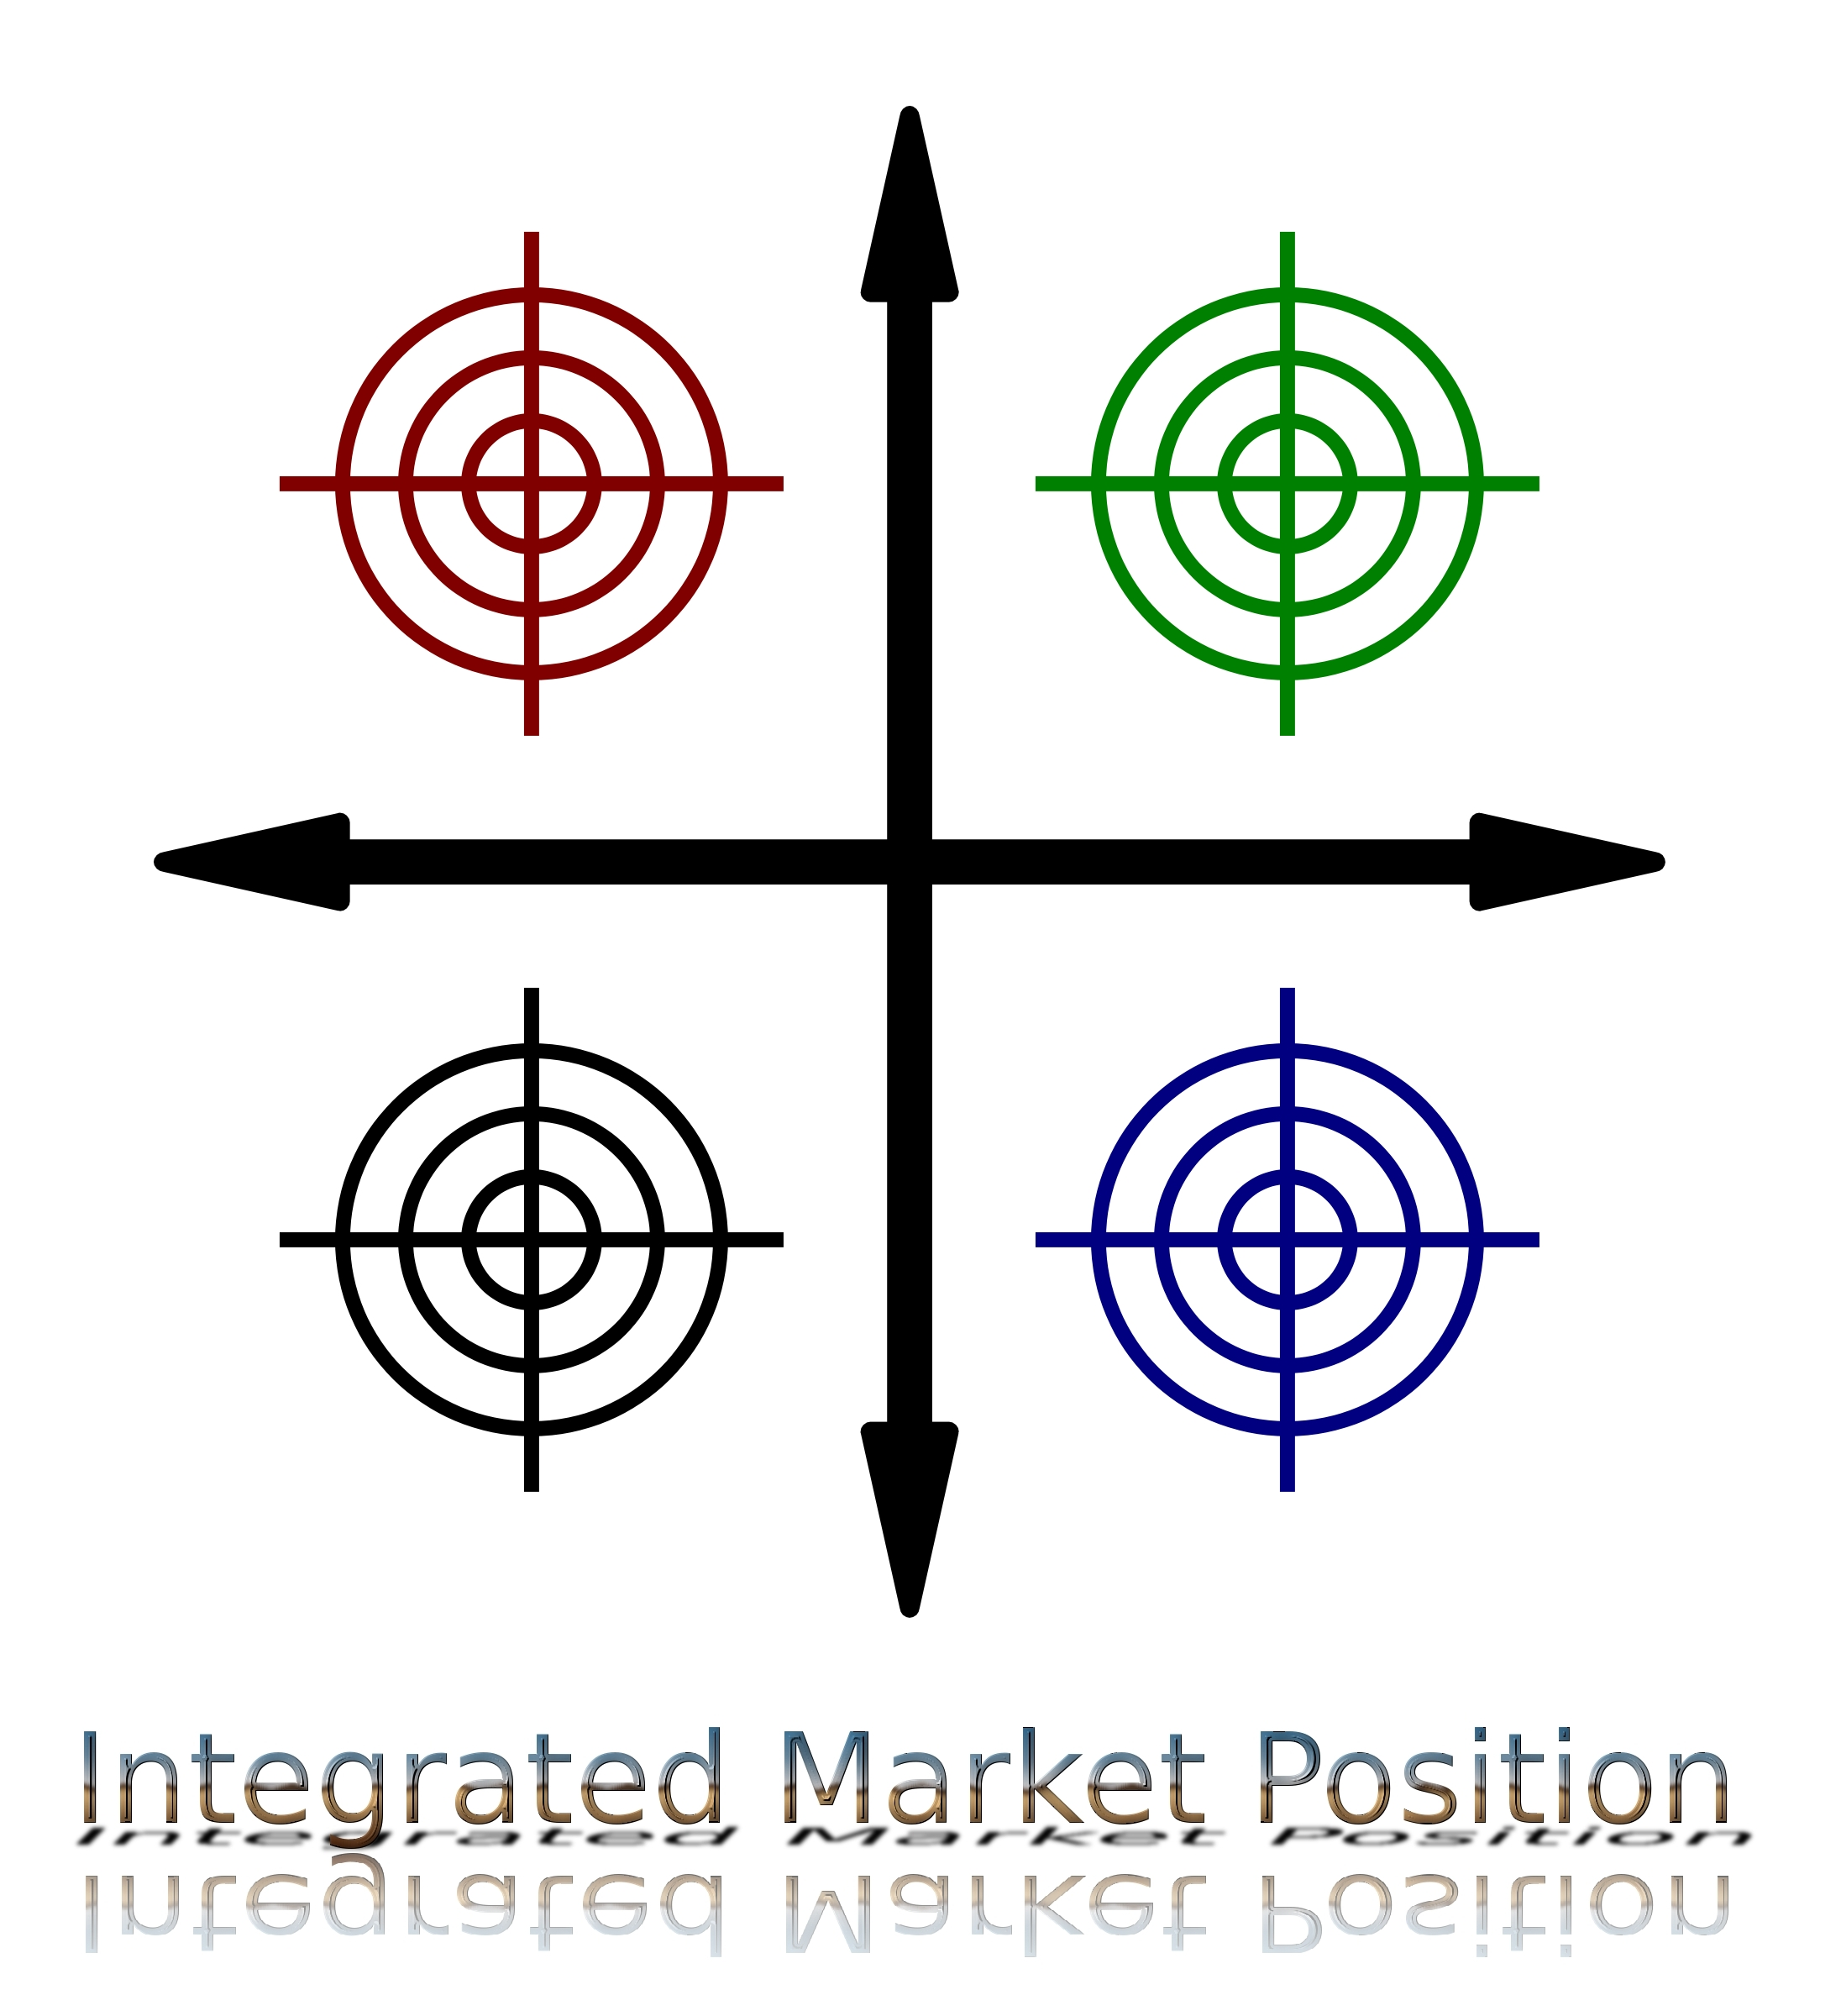

CRM Services Brochure

Welcome to Our CRM Solutions
At Integrated Market Position TM, we understand the importance of customer relationships. Our comprehensive CRM services are designed to help you build, manage, and nurture strong connections with your clients.

Why Choose Our CRM Services?
- Tailored Solutions: We provide customized CRM solutions that align with your unique business needs.
- User-Friendly Interfaces: Our CRM systems boast intuitive interfaces, ensuring a seamless user experience for your team.
- Data Security: Rest easy knowing that your customer data is in safe hands with our robust security measures.

Our Services

1. CRM Implementation
Our expert team will guide you through the seamless integration of CRM into your business processes. From data migration to user training, we’ve got you covered.

2. Customization and Configuration
Tailor your CRM to suit your business requirements. We specialize in customizing fields, workflows, and reports to enhance your team’s productivity.

3. Training and Support
Ensure your team is proficient in utilizing the CRM to its fullest potential. We offer training sessions and ongoing support to address any queries or concerns.

4. Data Migration
Effortlessly transfer your existing data to the new CRM system without any loss or disruption. We handle the migration process with precision.

Get Started Today!
Contact us to discuss your customer management needs and explore the best solution for your business.
Phone: +92 343 270 2932
Email: crm@atrc.net.pk
Website: https://atrc.net.pk/dokuwiki/doku.php?id=products:ict:erp-crm-scm:crm_benefits

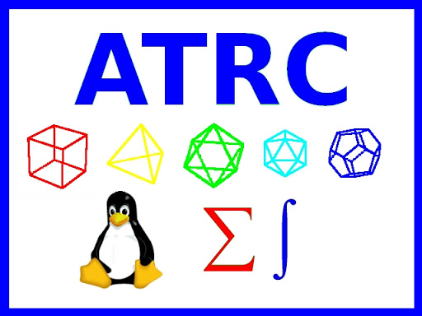
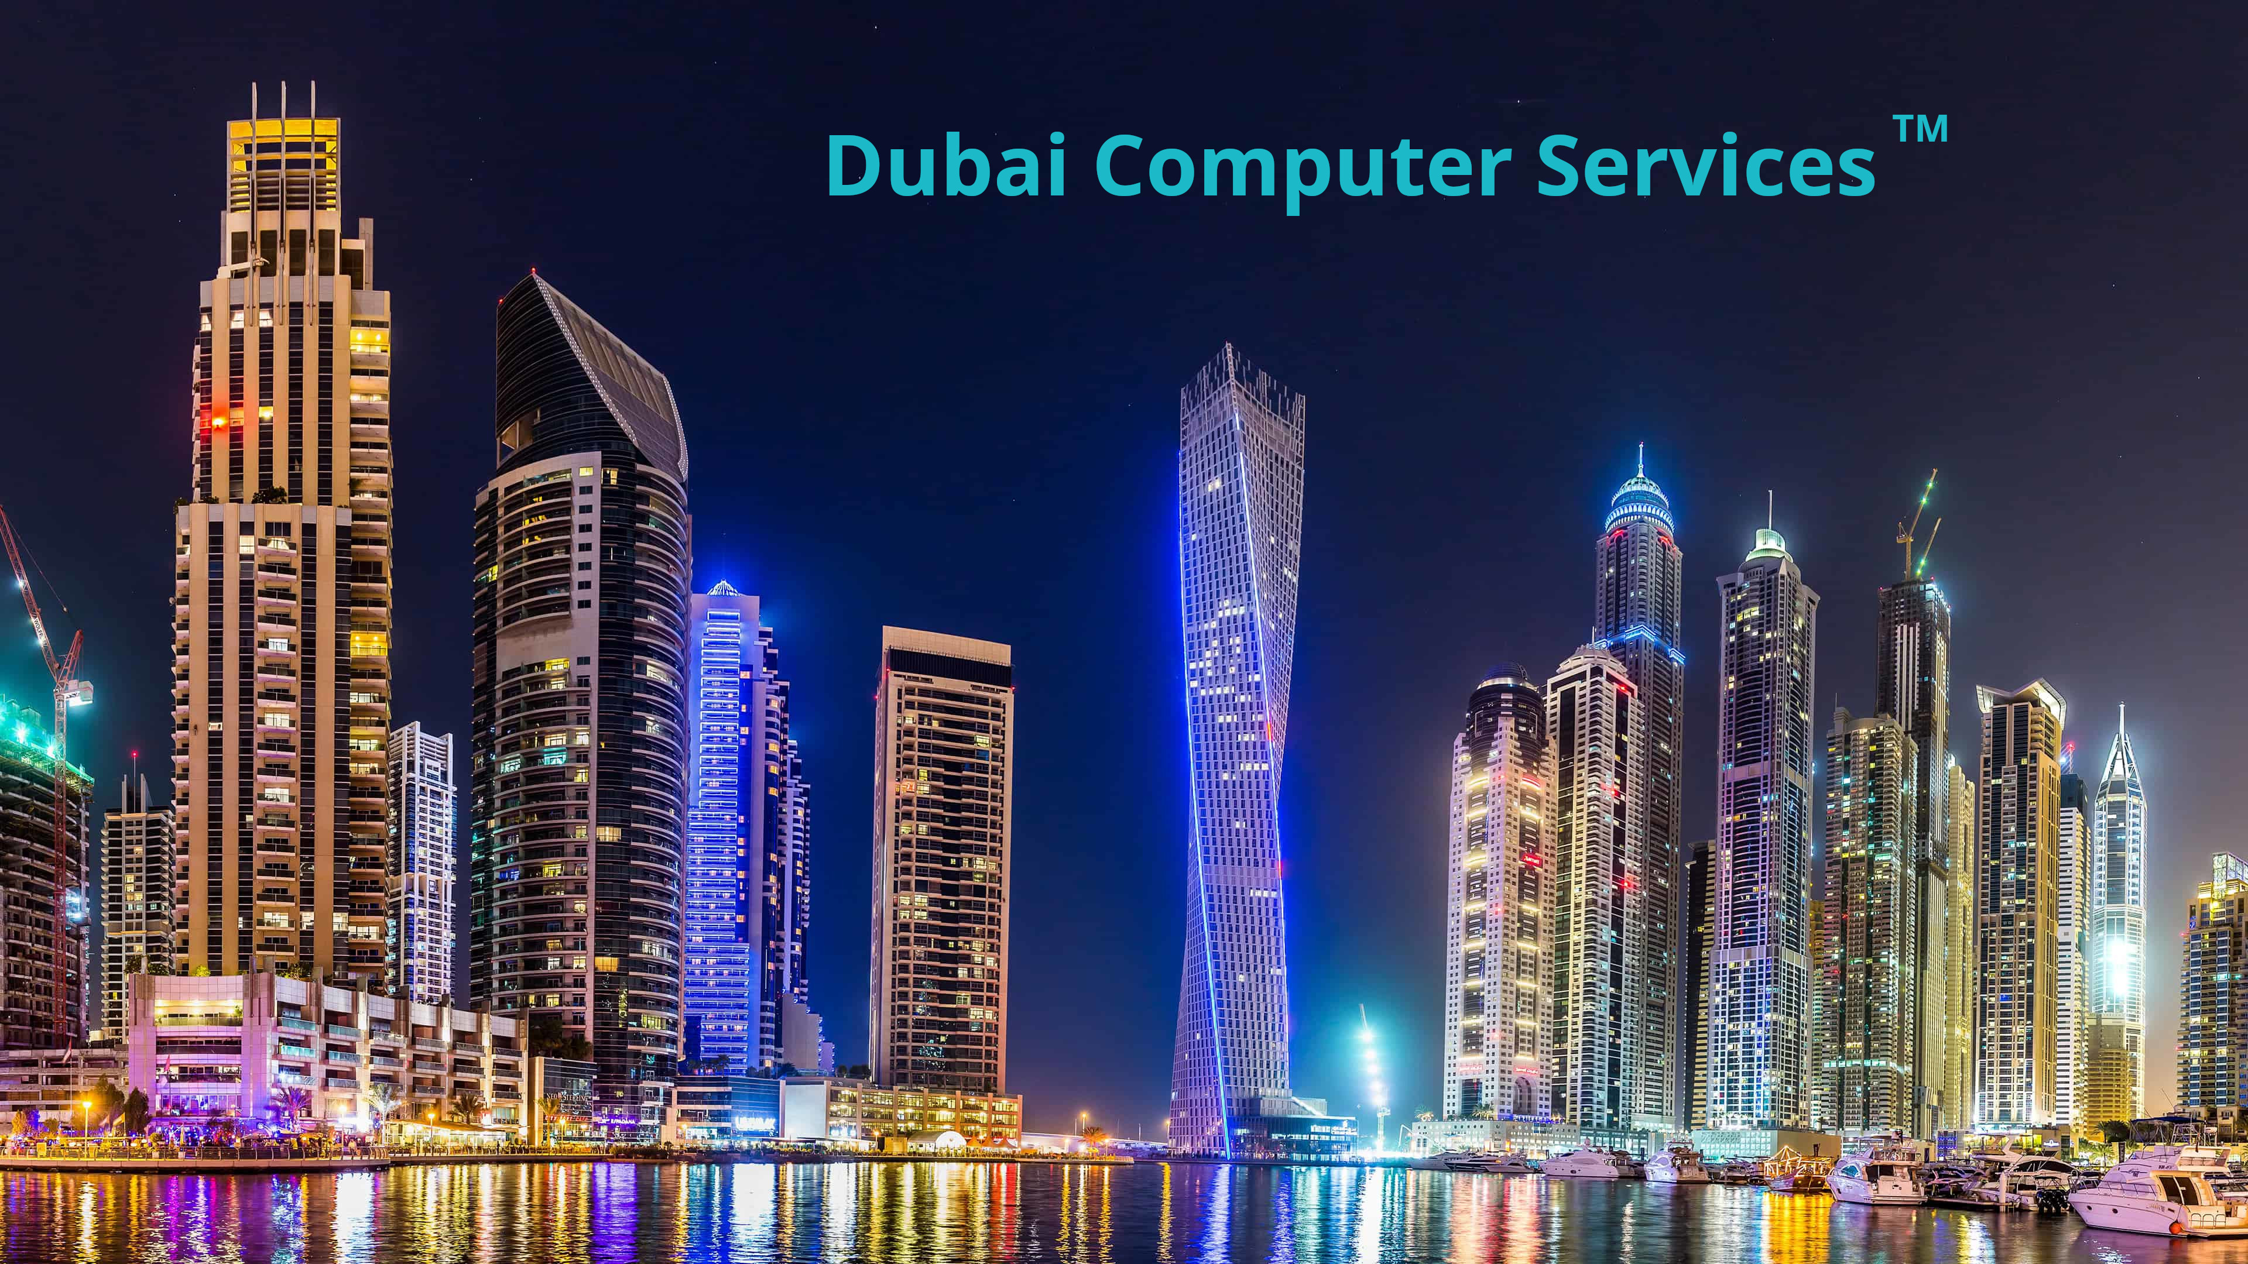
Integrated Market Position TM and Dubai Computer Services TM is a part of ATRC.

