
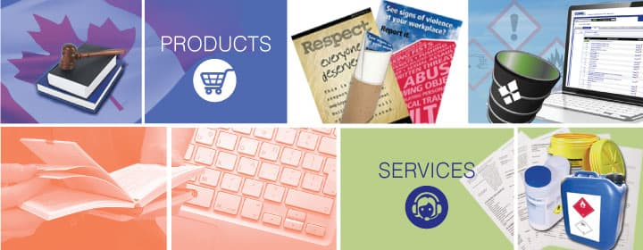

Our products, services, and brands


Comprehensive list of all products and services.

Date : 15 June 2023
Updated : 16 June 2023
26 June 2023

Table of contents

Our services


Enterprise software benefits ( in this document )
Enterprise Software development, support and training.
Enterprise software benefits (PDF) ( link )
Enterprise software benefits (ODT) ( link )

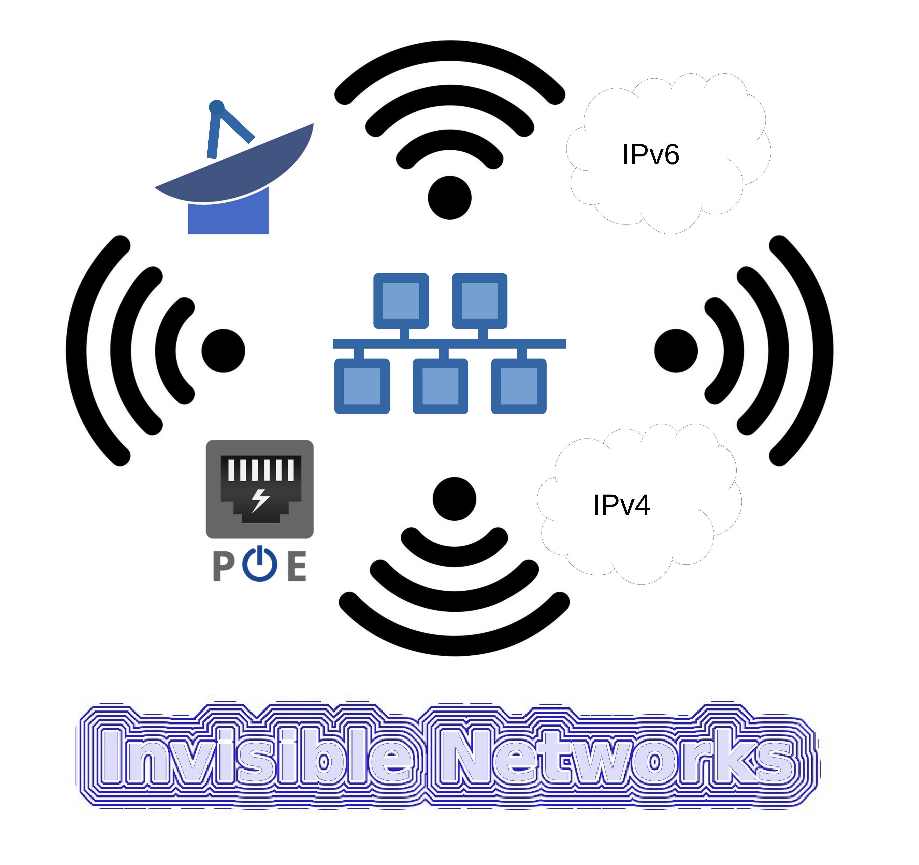
ICT → Communications → Wireless Networking
Brand Invisible Networks

ICT → Communications →
Computer and Network Security
Shared Internet Office Solutions
Email Servers and Mobile Device Support
Fiber connection. ( with partners )
Satellite connection. ( with partners )
Starlink connection.
VPNs
VoIP Gateways.
VoIP connections for PBXs.
Network Monitoring and Management

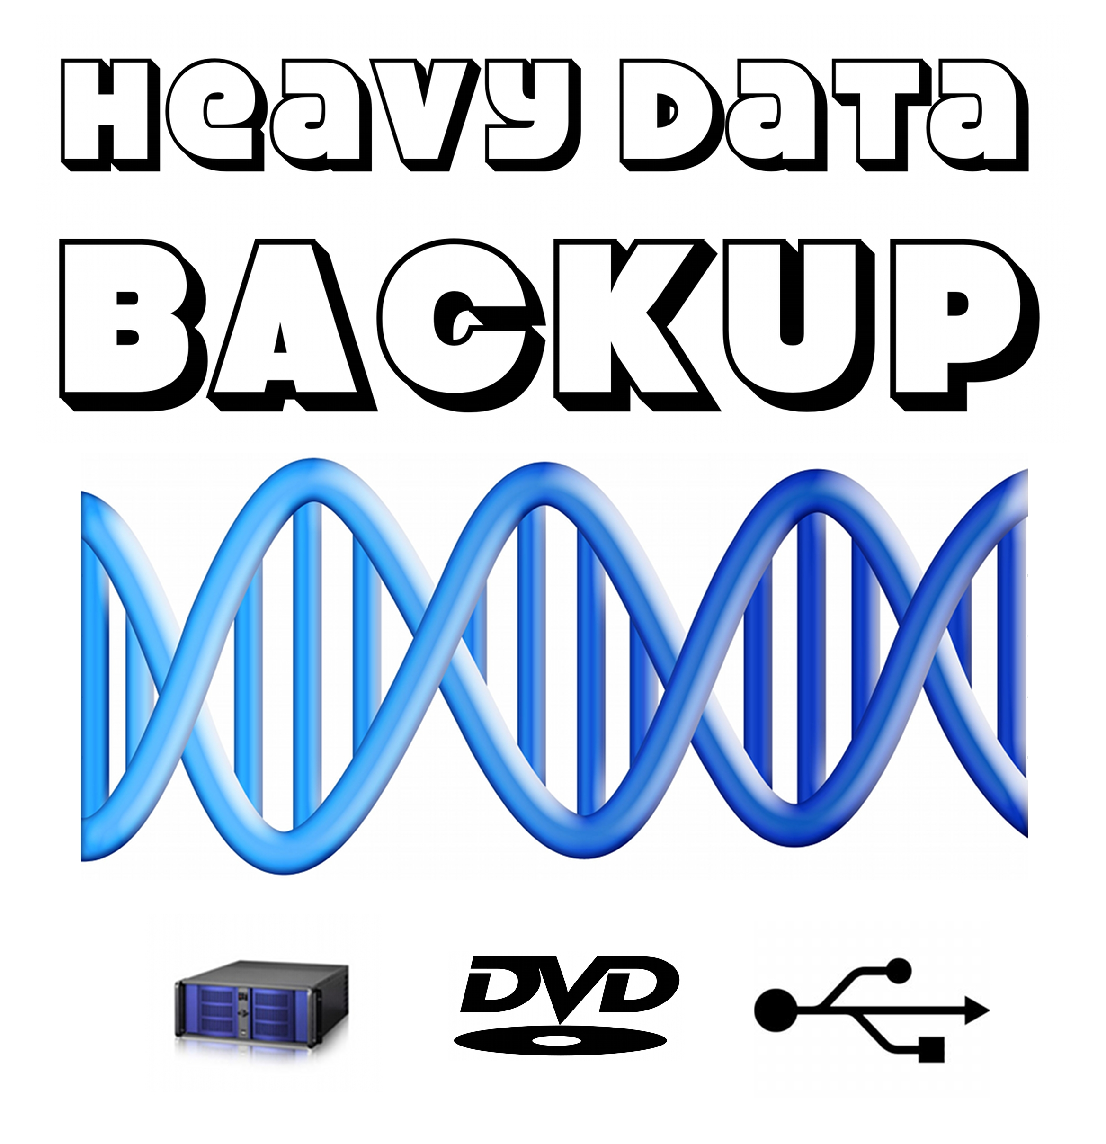
ICT → Business Continuity → Disaster Recovery →
Data Backup and Recovery
Brand heavy data backup.
Heavy Data Backup TM ( link )

ICT → Business Continuity → Remote Data Backup

ICT → Internet Services → Servers
Awesome Server Hosting Rates ( Link )
Wordpress hosting ( link )
ICT → Troubleshoot and Repair
Tech Support Rates ( link )

ICT → Troubleshoot and Repair

ICT → Project management
Support for Open Project. Project Management systems

Human Resource Management system features
ICT → Server Installation and Support
ICT → Anti-virus and Internet Security Solutions
ICT → Managed Services
ICT → Website Design and Hosting
ICT → Technology Consulting
ICT → Remote Managed Services

ICT → Office Relocation and Setup ( with partners )
ICT → Purchase a Computer ( with partners )

ICT → Training → Software Usage Training

ICT → Software products → Software made by MuftaSoft

Muftasoft Software ( link )
Brand MuftaSoft

ICT Services → Hardware Services

ICT Services → Software Services

ICT Services → Security Services

ICT Services → Networking Services

ICT Services → Data Services

ICT Services → Web Services

ICT Services → Support and Helpdesk Services

ICT Services → Cloud Services

ICT Services → Mobile Services

ICT Services → Training and Education Services

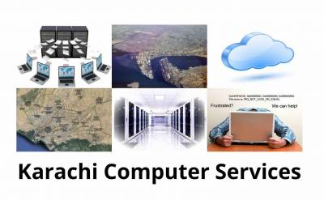
ICT → Services in Karachi
Brand Karachi Computer Services ( KCS )
Karachi Computer Services ( link )

Service → Audio Visual ( with partners )
MUFTASOFT
MuftaSoft TM is a software support company whose mission is to provide
third party support for such softwares so you can use them for any of your
mission critical applications knowing there is some company out there to
help you when you need it.

TAWANAI
Tawanai designs and implements power systems for industrial, commercial, rural, agricultural users, and 24x7 data centers.

Information and Communications Technology (ICT) Support Services
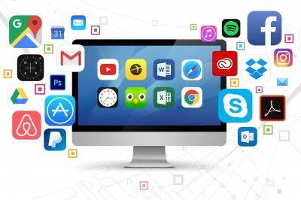

Support for Open Project. Project Management systems

Human Resource Management system features
Enterprise software services

Egroupware supported Virtual Machine.
Egroupware Features

Dolibarr Features
ERP Demo and Training for Dolibarr
Dolibarr ERP supported virtual machine.

ICT Security services

Support for opensource and integration with commercial softwares
DNS Server services
Linux Wifi Driver Installer by Muftasoft for Tenda USB Wifi
ATRC Muftasoft Linux IO Load stablizer
Electronic Medical Records
Ecommerce Service Rates
Linux course for IT people
Linux course for non technical people
ATRC Web, Mail, File and Proxy Server
Server Support
Video Conferencing support and training
Single command no parameters required scanning software for Linux by MuftaSoft
Software for Linux by ATRC and MuftaSoft
Kanban virtual machine
Support for popular brands
VoIP Services
VOIP Services for Businesses
Customer Relationship Management (CRM)
CRM Benefits
Telecoms Related Products and Services
Security Cameras (PDF)
Support for F-Droid
Information and Communications Technology (ICT) services for SMEs
Strategic Information and Communications Technology (ICT) consulting
Virtualization Xenserver support
Web Development
Bitcoin and cryptocurrency support
Support for turnkey appliances
Support levels defined for products and services
System Integration Services
Heterogeneous Systems Integration (HTML)
Heterogeneous Systems Integration (PDF)
Avail free support for free and opensource softwares (FOSS) from Muftasoft (TM). Special offer from us to you.
Lab and Factory integration for Quality control and traceability. Chromatigration TM By ATRC
Information Technology and Information Services Department related services.
IT-aSiMilator TM
Information Technology Service Management (ITSM), asset management and mobile device management
Point of Sale (POS) Systems
Benefits of POS systems
Point of Sale (POS) with inventory software
WIFI Server
Make your internet free by profiting from your internet connection. Our WIFI Server Benefits.
Backup Server
Backup Server Benefits
Document Management Server
Document Management Server Benefits
Document Management for Insurance Services

More Services
Company Profile
Intellectual property and licensing services
Linux Desktop exam and assessment
Linux for non technical people
Squid Proxy Support Services
Business Intelligence
Support for opensource softwares
Server for Small and Medium Enterprises (SMEs)
Endows 11.3 Professional Operating System

APPLIED TECHNOLOGY RESEARCH CENTER
High Performance, Reliable and Secure Solutions

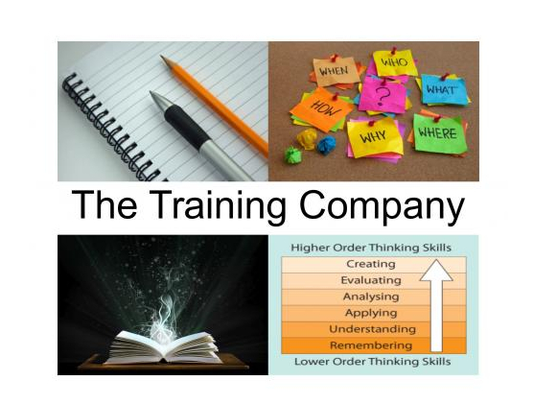

Service → TRAINING
Brand The Training Company

Training can improve business performance, profit and staff morale.

Having a high quality and comprehensive employee training development program enables you to strengthen the skills which your workforce already possesses as well as to build up knowledge where it is lacking. An employee training development program will bring all of your staff up to a higher standard of competency so that your entire team can share a common set of knowledge and skills. Such a program will repair any weak links that may exist in your organization and cause the workload to be more evenly spread among your workers.

MUFTASOFT

MuftaSoft TM is a software support company whose mission is to provide
third party support for such softwares so you can use them for any of your
mission critical applications knowing there is some company out there to
help you when you need it.


TAWANAI

Tawanai designs and implements power systems for industrial, commercial, rural, agricultural users, and 24x7 data centers.

ICT SECURITY SERVICES
Some of the best cybersecurity services honed from delivering 24x7 high reliability ISP systems.

CYBERSECURITY
Some of the best cybersecurity services honed from delivering 24x7 high reliability ISP systems.

DATA BACKUP SERVICES
Some of the most reliable and cost effective data backup services you can find on the planet.

Products / ICT / ERP CRM SCM / CRM

CRM Benefits


Increase Sales without increasing costs
Have a better sales forecast and a sales funnel at your fingertips
Get a 360 degree view of your customers with sales, marketing and customer service information
Track sales person activities in a matter of seconds
See Sales Goals Versus actuals for the organization, business line and by sales person
Track the success of your Marketing Campaigns
Implement and sustain excellent customer service
Improve First Contact Resolution
Increase Customer Satisfaction

Enterprise Software Benefits
There are many benefits of Enterprise software, which include improved productivity, increased efficiencies, decreased costs and streamlined processes.
Enterprise software includes CRM, ERP and SCM.
In today’s business world, where the quantum of business is too large, enterprise software is the one of the key factors that sets the business operational functions on and going.
The term denotes computer software with a multi-disciplinary approach, from accounting, billing, and order processing to security system of the enterprise, that runs the whole computer-based business house.
Unlike individual or small business concerns, here the parameters dealt are so vast in number that the management resorts to the various enterprise software to integrate the activities within their concern and also to co-ordinate with other business groups as well as their valuable client network.
Enterprise software, also known as enterprise application software has evolved leaps and bounds since its inception around the 1990s and today the entire world of business processes is run by large business establishments with the aid of enterprise software.

The need for enterprising software
By developing specific-purpose-oriented software, the enterprises stand to gain through increase in business logic functionality as well as productivity.
Be it large industrial houses, schools, multi-specialty hospitals, governmental agencies, retailers or other business groups, the functioning in general will be based on specific modules or systems which should essentially be addressed.
Enterprise software offers computer-based business tools such as:
- CRM (customer relationship management),
- BI (business intelligence),
- ERP(Enterprise Resource Planning),
- Human Resource Management,
- Online Payment Processing,
- Automated Billing Systems,
- Enterprise Content Management,
- IT Service Management,
- Email Marketing System, Call Center Support System, etc.

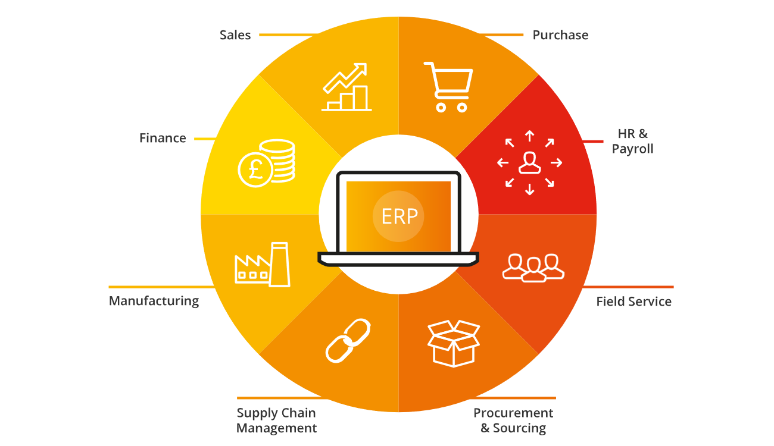
Competitive Advantage
It’s true that ERP implementations require a major investment, but there’s also an even bigger cost in not making the investment. While some manufacturers choose to stick to the tried and true methods of the past, others seek technology solutions. Manufacturers cannot afford to put off an ERP implementation while their competition invests in ERP and starts reaping the many benefits we’ll touch on below.
Improved Process Efficiency
An ERP solution eliminates repetitive processes and greatly reduces the need to manually enter information. The system will also streamline business processes and make it easier and more efficient for companies to collect data, no matter what department they’re working in.
Accurate Forecasting
Enterprise resource planning software gives your users, and especially managers, the tools they need to create more accurate forecasts. Since the information within ERP is as accurate as possible, businesses can make realistic estimates and more effective forecasts.
Department Collaboration
Nobody wants to run a siloed business with each department functioning separate from the other. Collaboration between departments is a crucial and often necessary part of the business. With the data entered into ERP systems being centralized and consistent, there’s no reason why departments can’t work together. The software also touches on almost every aspect of a business, thus naturally encouraging collaborative, interdepartmental efforts.
Scalable Resource
Did you know? Structured ERP systems allow the addition of new users and functions to grow the initially implemented solution over time. When your business is ready to grow or needs more resources, enterprise resource planning software should be able to facilitate that growth.
Integrated Information
No more issues with data spread across separate databases; all information will be housed in a single location. This means you can integrate platforms like your CRM software with the ERP system, keeping data consistent, accurate, and unique. Know your customer, their orders, and your inventory, all in one place.
Cost Savings
With one source of accurate, real-time information, ERP software reduces administrative and operations costs. It allows manufacturers to proactively manage operations, prevents disruptions and delays, breaks up information logjams and helps users make decisions more quickly. If you’ve chosen the right solution for your business, and the right vendor who meets your needs, you’re bound to see a powerful ROI.
Streamlined Processes
As manufacturers grow, their operations become more and more complex. Manufacturing software automates business operations cross-departmentally, providing accurate, real-time information to everyone utilizing the solution. ERP increases efficiency and productivity by helping users navigate complex processes, preventing data re-entry, and improving functions such as production, order completion and delivery. Streamlined, efficient processes throughout.
Mobility
An advantage of ERP solutions is having access to a centralized database from anywhere you work. Home, office, wherever, through our mobile-friendly solution and application.
Customized Reporting
ERP software helps make reporting easier and more customizable. With improved reporting capabilities, your company can respond to complex data requests more easily. Users can also run their own reports without relying on help from IT, saving your users time to use toward other projects.
Increased Productivity
Save time and increase productivity levels. Sound too good to be true? It’s not with ERP software. By having redundant processes automated, users have more time to work on other pressing projects and tasks. They’ll also be able to work easier since the solution was designed for ease-of-use.
Regulatory Compliance
A benefit of ERP software which sometimes goes unnoticed is how it ties well into regulatory compliance in the manufacturing industry. Powerful ERP solutions will keep track of regulations within the industry and monitor changes in compliance.
Flexible Systems
Modern ERP software systems are robust, flexible, and configurable. They are not a one-size-fits-all proposition but can be tailored to the unique needs of a business. ERP systems also can adapt to the ever-changing needs of a growing business, ensuring you won’t have to buy a new solution once your needs change or your business grows.
Customer Service
It’s easier to provide high-quality customer service using an enterprise solution. Sales and customer service people can interact with customers better and improve relationships with them through faster, more accurate access to customers’ information and history. You’ll also have access to marketing automation and contact center software, ensuring your customers are being interacted with consistently.
Data Reliability
ERP provides reliable data that can be accessed from different locations (if implemented in the cloud) and through multiple devices including tablets and smartphones. With the ability to update in real time, ERP improves data accuracy and consistency. ERP user data can also have additional security through firewalls and built-in protection resources.
Ready to learn more? Our enterprise solution experts are ready and willing to answer all your questions and help you get started on selecting the right solution for your business.
Features
Accounting
Get a real time view of your cash flow. Full fledged accounting module covering every aspect of book keeping.
HR & Payroll
Manage full employee life cycle right from onboarding, payroll, attendance, expense claims, assets to separation.
Manufacturing
Effectively maintain and manage multilevel bill of materials, production planning, job cards & inventory.
Sales & Purchase
Increase productivity and lower costs by managing your sales and purchase cycles, from purchase to sales orders

CRM
Win and retain more customers by optimizing sales process. Track leads, opportunities and send the quotes on the go.
Sales Force Automation
Automate routine sales, marketing, and support functions that take up valuable work time, giving you more time to concentrate on your customers. Create optimized workflows that help you reduce manual data entry, eliminate redundancies, and speed up your overall process.
Lead Management
Capture leads, automate lead scoring, identify leads that will convert, and follow up with detailed contact information.
Deal Management
Close more deals in less time. Track what stage your deals are currently in, and seize every opportunity at the optimal moment.
Contact Management
Get real-time insights about your customers, connect with them across channels, and build strong relationships.
Workflow Automation
Every time your team follows up with a lead or updates a field it requires significant manual work. Learn how to perform these tasks much faster, using workflows.
Projects
Deliver both internal and external projects on time, budget and profitability. Track tasks, timesheets and issues by project.
Helpdesk
Deliver a better service experience with an intuitive issue tracker and integrated knowledge base.
Asset Management
Maintain and Manage details of assets, their movement, value adjustment and depreciation.
Website
Some applications come with a fully featured content management with blogs, web pages and forms.

Dashboards
Create custom dashboards for everything you want to measure. Monitor and visualize your growth.
Quality Management System

Quality management is the act of overseeing all activities and tasks needed to maintain a desired level of excellence in tasks.
A Quality Management System is used to comply with ISO quality standards. The tool eliminates the need for paper records and replaces them with digital records. The application helps service and manufacturing companies to manage day-to-day work and instills full transparency across the system. It helps an organization in making Quality Goals and design Quality Procedures to achieve it.
Process Management
Does your sales team know what to do at each stage in your pipeline? With Blueprints, your sales team can find out the next move to make at any moment. Define your sales process for your whole team to follow.
Sales Process Builder
Bring your offline sales processes into your CRM and make sure all your sales reps follow it at every turn.
Processing Rules
Set up rules in your CRM based on your real-life sales processes. Assign leads to the right sales rep, approve discounts and validate sales data based on your criteria.
Review Process
Get clean data in your CRM. Define a process for your team to review incoming information, and approve or reject it with appropriate comments based on their quality.
Omnichannel
Converse in real time with customers and prospects. Get notified when someone interacts with your brand—whether they're browsing your website, reading an email, or talking about your brand on social media.
Email
Handle email communication completely. Send emails, associate emails to CRM records, and get email insights.
Telephony
Connect your telephony provider to make calls from within the CRM. Schedule calls, get reminders, and save call logs from every interaction.
Social
Monitor what people are saying about your brand online, and automatically capture new leads from social media that aren't in your CRM.
Customer portals
Facilitate prospects with a self-service portal where they can view your products and make purchasing decisions.
Analytics
The more your business grows, the more you need to know. Measure the performance of every sales activity, and break quotas down into achievable targets with the CRM's reports, analytics, and forecasts.
Reports
Real-time reporting gives you insight into a variety of metrics such as sales trends, marketing campaigns, activity reports, and team performance.
Analytical Components
Create dashboards, analyze trends, stay on top of your key performance indicators, and know where you stand on your targets.
Capabilities
Take a look at the different ways analytics can help your business grow by helping you make data-backed decisions.
Sales Enablement
With the right set of tools, your team will never have to struggle. Generate price quotes, and access sales scripts. Permit your customers, vendors, and partners to view, add, or edit information through portals from within your CRM saving your team time and effort.
Quotes and Finance
Generate quotes, invoices, and orders with access to inventory, shipping, and subscription information.
Partner Portals
Grow your business by giving partners access to create and nurture leads, manage inventory, and view their contacts.
Calendar
Access all your calendars from one system. Prioritize meetings with multiple reminders and convert them into recurring events by checking a box.
Performance Management
Accelerate your sales team's productivity with accurate forecasts of potential revenue, and make use of productivity games to exceed your sales quotas. You can categorize customers quickly, set up multiple currencies, use AI predictions to prioritize leads and deals likely to convert, and track website visitors to convert more prospects.
Forecasting
Make more accurate forecasts. Predict future sales, and measure them against current sales.
Territory Management
Categorize customers based on relevant criteria and assign the right sales reps to reach out to them. Exceed quotas with region-wide sales insights.
Gamification
Encourage your team to exceed sales quotas by awarding badges and trophies when tasks are completed.

Marketing Automation
Get your marketing and sales teams on the same page. Generate new leads, execute targeted email marketing campaigns, and compare ad spending to sales revenue with the Google Ads integration.
Customer Segmentation
Segment your contacts and target them with personalized campaigns to improve engagement, retention, and ROI on marketing campaigns.
Lead Nurturing
Strengthen your relationship with your leads by nurturing them with relevant content at every stage of your funnel.
Google Ads Integration
Compare your Google Ad campaigns against sales to monitor your spending and determine which campaigns are working and which aren't.
Event Management
Use CRM to communicate with event attendees, send invites to your contacts or leads, and connect with new leads that you've collected from the event.
Security
Your security is our top priority. We understand that every organization needs to strike the right balance between protecting their customers' data and giving employees the freedom to get their work done. Our systems meet both of these requirements.
Roles, Profiles, and Teams
Assign roles for users, define permissions, and control access to information in the system.
Data Security
With comprehensive data security features, protect both your data and your customers' from unauthorized access.
Compliance
Ensure you data collection and sales process is compliant with privacy regulations using our comprehensive set of compliance features.

Logistics
3PL Management
3PL is a service that allows you to outsource operational logistics from warehousing, all the way through to delivery, and ultimately enables you to focus on other parts of your business.
Third-party logistics companies provide any number of services having to do with the logistics of the supply chain. This includes transportation, warehousing, picking and packing, inventory forecasting, order fulfillment, packaging and freight forwarding.
Barcoding/RFID
Cross Docking
Fleet Management
Inventory Management
Order Management
Shipping Management
Supplier Management
Transportation Management
Inventory Management
Manage inventory at multiple levels: bin location, product, lot/serial number, and expiration date
Manage multiple facilities across multiple regions
Manage bin locations and bulk storage areas within each storage facility
Make adjustments to quantity and bin location during inventory activities
Track reasons for adjustment (i.e. expiry, damage, loss)
Export suggested cycle count for each location based on last inventory date
Remove quantity from inventory due to expiry, damage, or recall

Electronic Stock Card
Our system supports any type of item including, but not limited to, medications, medical supplies and devices, office supplies, and building materials. In addition, the software can be used to track the location of fixed assets like automobiles, IT equipment, and hospital furniture.
Store metadata about each item, including cost, suppliers and manufacturers, category/classification, and substitutions.
Create custom attributes for temperature requirements, hazardous material class, and import/export requirements (e.g. for controlled substances).
View quantity on hand within each inventory location by bin location, lot/serial number, and expiration date
View stock history including debits, credits, and inventory adjustments
Stock Movements
Intuitive workflows to manage movement of stock from a supplier to depot, from depot to depot, and from depot to consumption location.
Ability to base a stock movement on a preset stock list (i.e. monthly replenishment)
Ability to edit quantity in stock movement based on availability of stock
Ability to keep track of original request to inform forecasting
Ability to act on suggested substitutions during stock movement workflow
Automated picking based on first-expiry-first-out (FEFO) algorithm
Ability to export and print picklist
Ability to pack items by pallet and box
Ability to add stock movement metadata including date, tracking number, comments
Ability to export packing lists and customized customs clearance documentation
Ability to upload and store other documentation
Inventory Tracking
Adjust inventory quantity and remove quantity due to expiry and damage.
Track lot/serial number and expiration date through workflows, including automation based on FEFO during picking
Easily identify affected inventory in the event of a recall
View and export dashboard reports on expiring stock
Access information about incoming shipments and pending outgoing shipments for each item by location

Dashboard
Useful indicators to help inform stakeholders on important decisions that need to be made and advise users on what they neeed to work on next.
Stock value
Inventory summary
Bin location summary
Expiring stock summary
Fast movers
Global search
Product tags
Recent activities
Flexible Location Hierachy
Organize and manage stock within multiple facilities, thousands of bin locations, receiving and staging area, supply closets, etc
Location Groups (geographic region)
Location (facility, storage area, room, closet, locked cabinet, crash cart)
Internal locations (bin location, receiving area, staging area, cross-docking, bulk storage)

Reporting
Supports utilization and request (demand) tracking; Includes out-of-the-box reporting features for planning and warehouse management; Customized reports and integration with other software can be developed
Dashboard Indicators
Consumption Report
Stockout Report
Expiration Report
Transaction Report
Stock Analytics
Quantity On Hand Report

Security
Assign permission levels by role
Auditing of user actions, includes automatic created & updated timestamps for all major transactions
Multiple roles available (Superuser, Manager, Read-only)
User access can be restricted by location
Ability to authenticate using directory service (i.e. LDAP)
Configuration of user roles and permissions (coming soon)

Insurance
QUOTE & BUY - Online, direct to market policy sales
RATING ENGINE - Powerful, flexible & fast
PROPOSAL FORMS - Dynamic, user friendly & configurable
EXCEL RATING SHEETS - Configure rating rules using Excel
QUOTE AGGREGATION - Compare quotes from many providers
SINGLE QUOTE - Provide quotes from an individual provider
PREMIUM COLLECTION - Integrate with a wide range of payment providers
MOBILE READY - Serve the mobile market as well as the traditional
PRODUCT DEVELOPMENT - Develop & tailor you own product lines
GENERAL LINES - Supports general lines insurance
COMMERCIAL LINES - Supports commercial lines insurance
NICHE PRODUCTS - Deliver niche products efficiently
REFERRAL MANAGEMENT - Process referrals quickly & efficiently
DOCUMENT TEMPLATES - Template policy documents using PDF Forms
ISSUE DOCUMENTATION - Automatically issue documentation
LOCALIZATION - Support multi language & currency
REGIONAL TAX - Configure regional insurance tax requirements
SERVICE INTEGRATION - Designed to integrate with back office & third party services
BORDEREAU REPORT - Generate bordereau reports quickly & easily
A bordereau is a report prepared by an insurance company for a reinsurance company detailing either the assets that are covered in part by the reinsurance firm or the actual claims that have been made for damage to property protected by a contract between the two companies.
REPORTING AND MI - Realize reporting & management information requirements
USER DASHBOARD - Customisable user dashboard
B2B - Deliver products through agents
B2C - Deliver products direct to market
DATA MANAGEMENT - Powerful, flexible data management & export
DATA ANALYSIS - Collate point in time data for analysis
COMBINE DATA SOURCES - Analyze multiple sources & types of data

ICT Services
Category: Hardware Services

1. Computer assembly: Building and configuring custom computer systems based on customer requirements.
2. Hardware installation: Installing and setting up computer components, such as graphics cards, memory, and hard drives.
3. Computer diagnostics: Identifying and troubleshooting hardware issues to determine the cause of computer malfunctions.
4. Hardware upgrades: Upgrading computer components to improve performance, such as installing a faster processor or adding more RAM.
5. Data recovery: Retrieving lost or deleted data from malfunctioning or damaged hard drives.
6. Hardware repair: Fixing hardware-related problems, including replacing faulty components and repairing physical damage.
7. Laptop repairs: Repairing issues specific to laptops, such as screen replacements, keyboard repairs, and battery replacements.
8. Peripheral setup: Configuring and installing peripheral devices like printers, scanners, and external storage devices.
9. Networking setup: Assisting with the installation and configuration of wired or wireless network connections.
10. System cleaning: Cleaning the internal components of computers to remove dust and optimize performance.

ICT Services
Category: Software Services

11. Operating system installation: Installing and configuring operating systems, such as Windows, macOS, or Linux.
12. Software installation: Installing and setting up various software applications, including productivity tools, antivirus software, and multimedia programs.
13. Software updates: Keeping software applications up to date with the latest patches and security updates.
14. Virus and malware removal: Scanning and removing malicious software from infected computers.
15. Data backup and recovery: Implementing backup solutions to protect data and recovering lost or corrupted data.
16. Software troubleshooting: Identifying and resolving issues with software applications, such as crashes or compatibility problems.
17. Software training: Providing instruction and guidance on how to use specific software programs effectively.
18. Virtual machine setup: Configuring and setting up virtual machines for running multiple operating systems on a single computer.
19. Software customization: Modifying and tailoring software applications to meet specific customer requirements.
20. Cloud services setup: Assisting with the setup and configuration of cloud-based services, such as email, file storage, and collaboration tools.

ICT Services
Category: Security Services

21. Firewall setup and configuration: Installing and configuring firewall systems to protect computer networks from unauthorized access.
22. Network security assessment: Assessing the security of computer networks to identify vulnerabilities and recommend solutions.
23. Intrusion detection and prevention: Implementing systems to detect and prevent unauthorized access or malicious activities.
24. Data encryption: Implementing encryption methods to protect sensitive data from unauthorized access.
25. Security software installation: Installing and configuring antivirus software, anti-malware tools, and other security applications.
26. Security audits: Evaluating the overall security posture of computer systems and recommending improvements.
27. Security training and awareness: Providing training programs to educate customers on best practices for cybersecurity.
28. Penetration testing: Conducting controlled simulated attacks to identify vulnerabilities in computer systems.
29. Incident response: Assisting with the investigation, containment, and recovery process in the event of a security breach.
30. Security policy development: Helping organizations develop comprehensive security policies and procedures.

ICT Services
Category: Networking Services

31. Network installation: Setting up and configuring computer networks, including routers, switches, and network cabling.
32. Network troubleshooting: Identifying and resolving issues with network connectivity, slow performance, or intermittent outages.
33. Network upgrades: Upgrading network equipment or expanding network capabilities to accommodate increased traffic or user demands.
34. Wireless network setup: Configuring wireless routers and access points to provide wireless network connectivity.
35. Network monitoring: Implementing monitoring tools to track network performance, identify bottlenecks, and proactively address issues.
36. VPN setup: Configuring virtual private network connections to establish secure remote access to corporate networks.
37. Network security: Implementing security

measures, such as encryption and access controls, to protect network infrastructure.
38. Network optimization: Analyzing network performance and making adjustments to optimize speed, reliability, and efficiency.
39. IP address management: Managing IP address allocation and ensuring proper configuration and assignment.
40. Network documentation: Creating and maintaining accurate documentation of network configurations and setups.

ICT Services
Category: Data Services

41. Data recovery and restoration: Retrieving lost or corrupted data from storage devices and restoring it to a usable state.
42. Data backup solutions: Implementing backup strategies and solutions to ensure data protection and disaster recovery.
43. Data migration: Transferring data from one system or storage medium to another, such as upgrading to a new server or cloud platform.
44. Data cleansing: Cleaning and organizing data to remove duplicates, correct errors, and improve data quality.
45. Database management: Administering and maintaining databases, including performance optimization, security, and backups.
46. Data analytics: Analyzing and interpreting data to identify patterns, trends, and insights for business decision-making.
47. Data integration: Combining data from different sources or systems to create a unified view for analysis or reporting.
48. Data security and privacy: Implementing measures to protect data integrity, confidentiality, and compliance with regulations.
49. Data warehousing: Designing and building data warehousing solutions for storing and accessing large volumes of structured data.
50. Data visualization: Creating visual representations of data to facilitate understanding and communication of complex information.

ICT Services
Category: Web Services

51. Website design and development: Creating visually appealing and functional websites tailored to customer requirements.
52. Website hosting: Providing server space and infrastructure to host websites and make them accessible on the internet.
53. Domain registration: Assisting customers in registering and managing domain names for their websites.
54. E-commerce solutions: Developing online stores with features like product catalog, shopping carts, and secure payment gateways.
55. Content management systems (CMS): Implementing CMS platforms, such as WordPress or Drupal, for easy website content management.
56. Search engine optimization (SEO): Optimizing websites to improve their visibility and ranking in search engine results.
57. Website maintenance: Performing regular updates, backups, and security checks to keep websites running smoothly.
58. Web application development: Creating custom web-based applications to address specific business needs or workflows.
59. Website migration: Transferring websites from one hosting provider or platform to another without data loss or downtime.
60. Web analytics: Setting up tracking and analysis tools to monitor website traffic, user behavior, and performance metrics.

ICT Services
Category: Support and Helpdesk Services

61. Remote technical support: Providing assistance and troubleshooting remotely via phone, chat, or remote desktop tools.
62. Helpdesk support: Resolving customer inquiries and issues related to hardware, software, or network problems.
63. Software training and support: Assisting customers with using software applications and addressing any related questions or problems.
64. Email support: Managing customer email inquiries, troubleshooting email issues, and providing solutions.
65. Hardware maintenance contracts: Offering maintenance agreements to ensure regular servicing and support for computer hardware.
66. System monitoring: Monitoring computer systems for performance, availability, and potential issues, and taking proactive action.
67. On-site support: Dispatching technicians to customer locations for hands-on troubleshooting and issue resolution.
68. IT asset management: Tracking and managing IT assets, including hardware, software licenses, and warranties.
69. User account management: Creating, modifying, and managing user accounts and access permissions.
70. Incident management: Logging, tracking, and resolving incidents reported by customers or end users.

ICT Services
Category: Cloud Services

71. Cloud migration: Assisting with the transition of applications, data, and infrastructure to cloud-based platforms.
72. Cloud infrastructure setup: Configuring and deploying virtual servers, storage

, and networking in cloud environments.
73. Cloud security: Implementing security measures to protect data and applications in cloud environments.
74. Cloud backup and recovery: Setting up automated backups and recovery mechanisms for data stored in the cloud.
75. Cloud resource optimization: Analyzing cloud usage and making adjustments to optimize costs and performance.
76. Cloud consulting: Providing guidance and recommendations on cloud adoption strategies and best practices.
77. Cloud application development: Building and deploying cloud-native applications or migrating existing applications to the cloud.
78. Cloud monitoring and management: Monitoring and managing cloud resources, optimizing performance, and ensuring availability.
79. Serverless computing: Designing and developing applications using serverless architectures for scalability and cost efficiency.
80. Cloud-based collaboration: Setting up and configuring cloud-based tools for team collaboration and communication.

ICT Services
Category: Mobile Services

81. Mobile app development: Creating native or cross-platform mobile applications for iOS and Android devices.
82. Mobile app testing: Conducting comprehensive testing to ensure the functionality, usability, and performance of mobile apps.
83. Mobile app optimization: Analyzing and optimizing mobile apps for speed, responsiveness, and user experience.
84. Mobile app security: Implementing security measures to protect mobile apps and users' sensitive data.
85. Mobile device management: Managing and securing mobile devices used in an organization, including configuration and policy enforcement.
86. Mobile app deployment: Assisting with the distribution and deployment of mobile apps to app stores or enterprise app catalogs.
87. Mobile app analytics: Implementing tracking and analysis tools to gain insights into app usage and user behavior.
88. Mobile payment integration: Integrating payment gateways into mobile apps to facilitate secure transactions.
89. Mobile app updates and maintenance: Providing ongoing support, bug fixes, and updates for mobile applications.
90. Mobile app UI/UX design: Designing intuitive and visually appealing user interfaces for mobile applications.

ICT Services
Category: Training and Education Services

91. IT certifications training: Providing training programs to help individuals prepare for industry-recognized IT certifications.
92. Technology workshops: Conducting workshops on various technology topics, such as programming languages, cybersecurity, or data analytics.
93. IT skills development: Offering training and courses to enhance technical skills in areas like networking, programming, or database management.
94. Technology consulting: Providing expert advice and guidance on technology strategies, implementation, and best practices.
95. Software development training: Teaching individuals how to code and develop software applications using programming languages.
96. Cybersecurity training: Educating individuals on best practices for securing their personal or organizational digital assets.
97. Digital literacy training: Assisting individuals in developing basic computer skills and understanding digital technologies.
98. Project management training: Training individuals on project management methodologies, tools, and techniques.
99. Business intelligence training: Teaching individuals how to gather, analyze, and interpret data to make informed business decisions.
100. IT leadership and management training: Offering programs to develop leadership and management skills for IT professionals.

CONTACT

Contact us for some great solution.

C-55 Block A KDA Officers,
Karachi, 75260, Pakistan
+92 343 270 2932

Email : info@atrc.net.pk
Linkedin
Twitter
Facebook
Instagram

