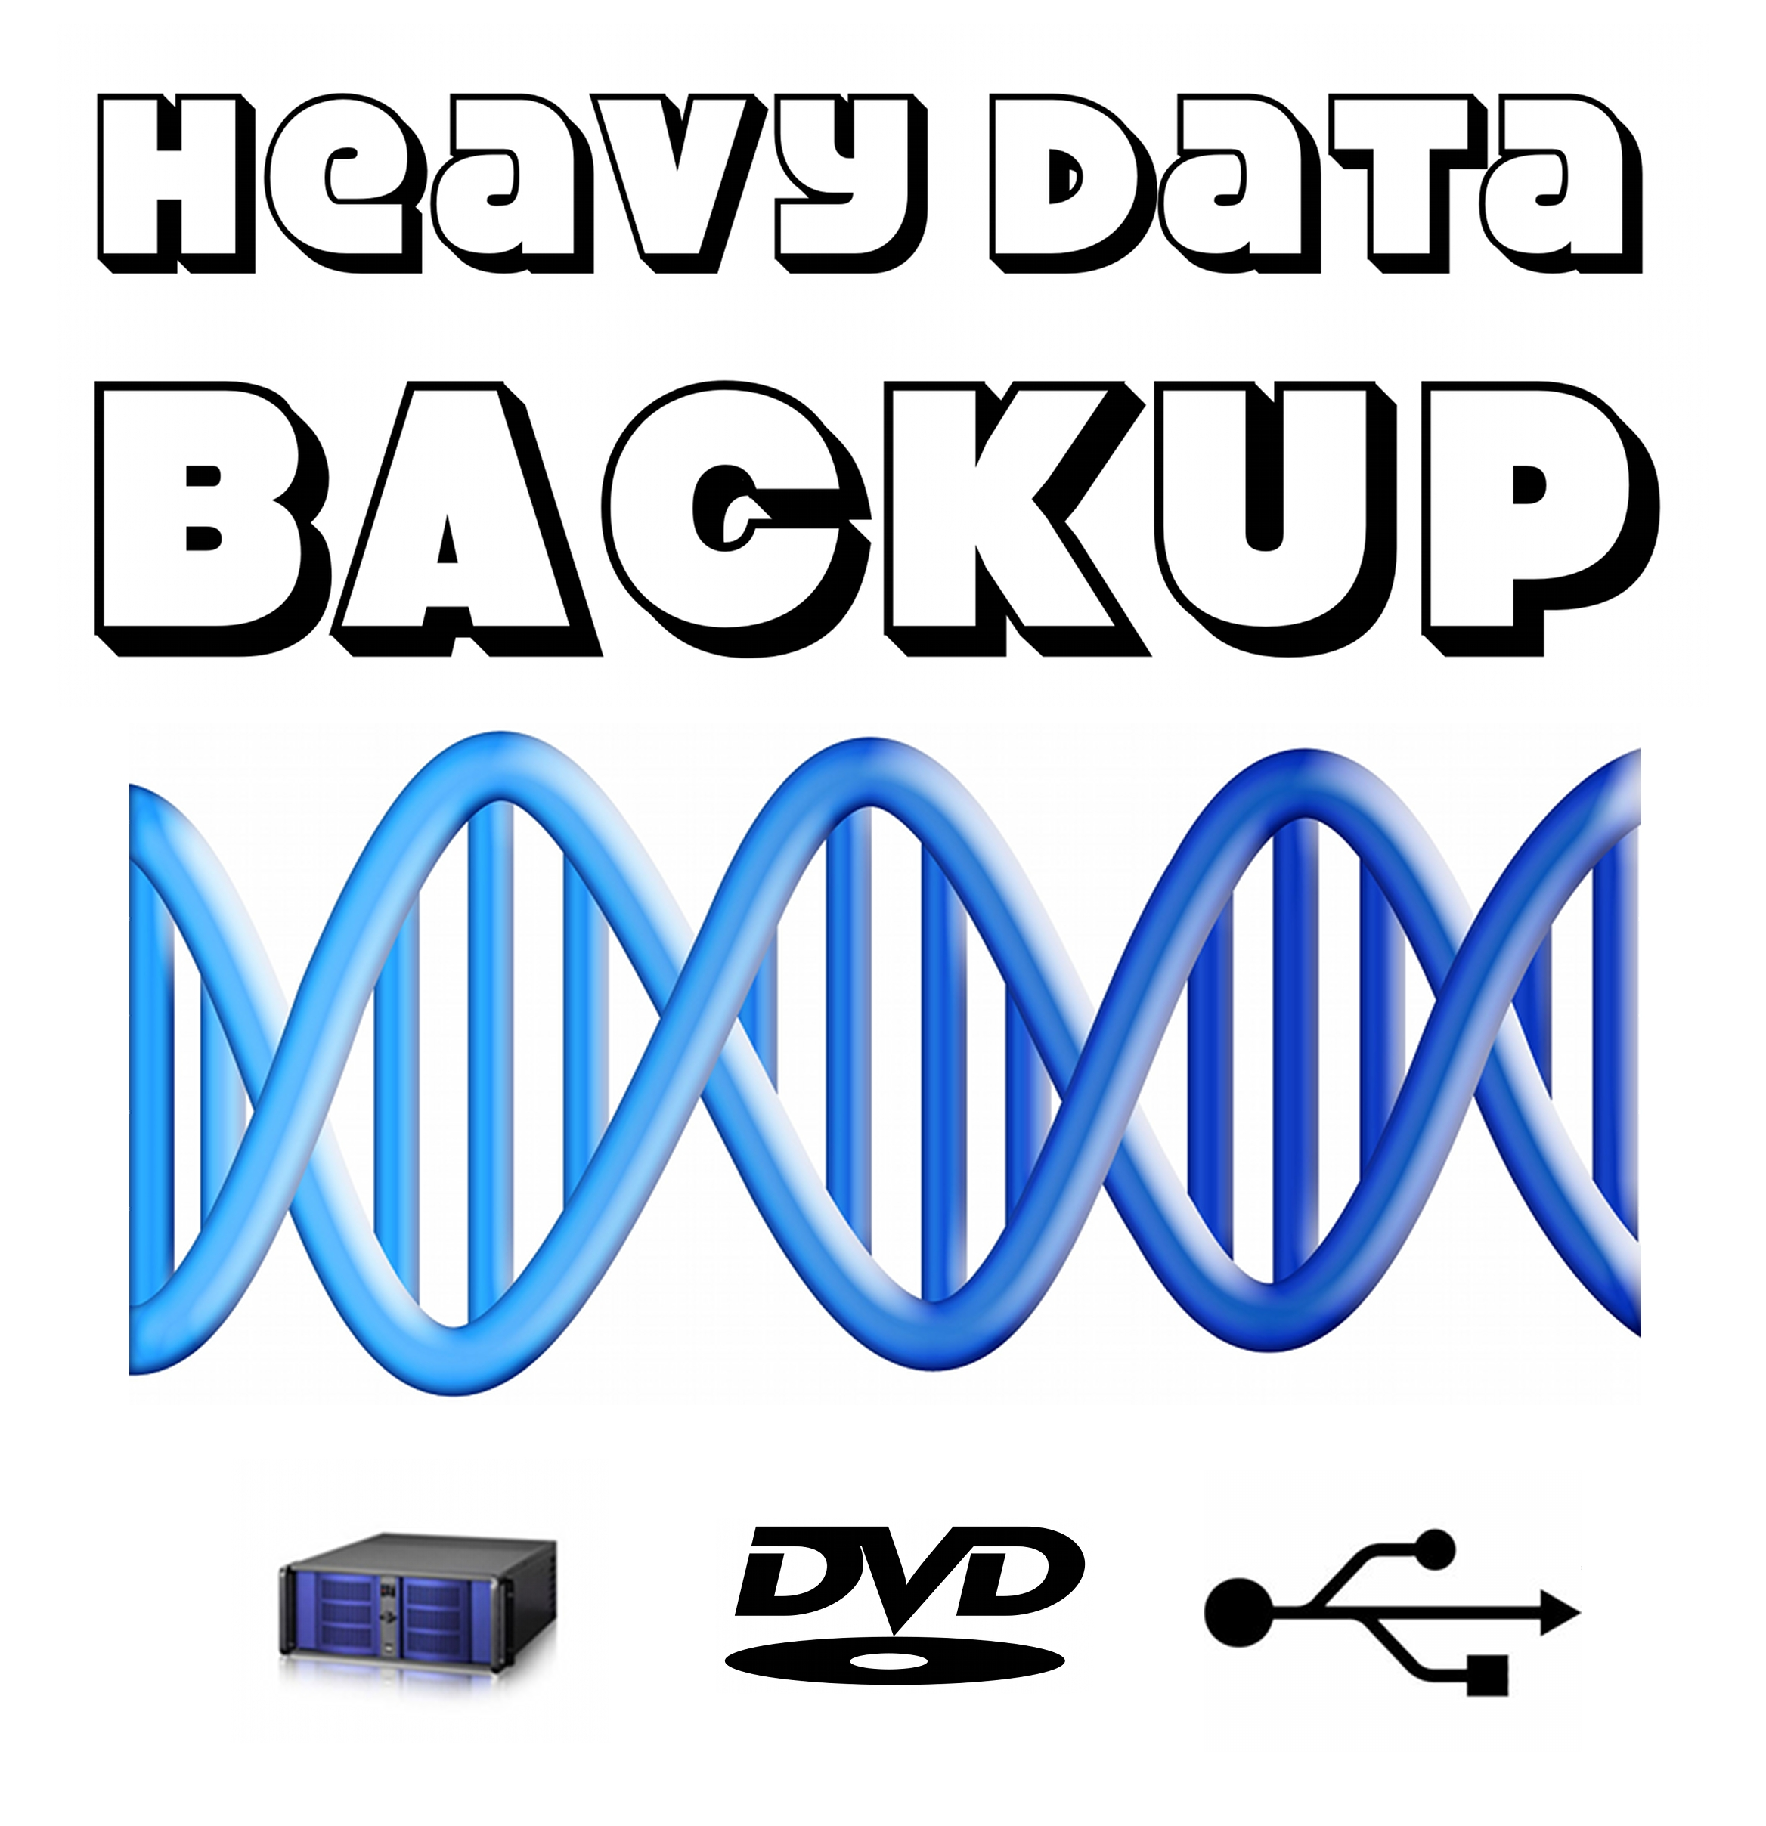

Welcome to Heavy Data Backup TM Backup Services
At Heavy Data Backup TM, we understand the importance of safeguarding your data. Our backup services provide a robust solution to ensure the security and availability of your critical information. We specialize in offering special restoring services which is an industry first.

Why Choose Heavy Data Backup TM Backup Services?
- Reliable Protection: Our advanced backup solutions guarantee the reliability and integrity of your data.
- Restoring Services.
- Automated Backups: Enjoy peace of mind with automated and scheduled backups to prevent data loss.
- Secure Storage: We prioritize the security of your data by storing it in encrypted, state-of-the-art data centers.
- Flexible Options: Choose from a range of backup plans tailored to your specific needs and budget.

Our Services

1. Data Backup

Automated Backups
- Set up automatic, regular backups to ensure your data is always up to date.

Incremental Backups
- Save bandwidth and storage space with incremental backups that capture only changes since the last backup.

2. Cloud Storage

Secure Cloud Solutions
- Store your backups in our secure cloud environment for easy accessibility and enhanced data protection.

Scalable Storage Plans
- Choose from scalable cloud storage plans that grow with your business.

3. Disaster Recovery

Quick Restoration
- Minimize downtime with our rapid data recovery services in the event of a disaster.

Business Continuity
- Develop a comprehensive disaster recovery plan to keep your business running smoothly.

Get Started Today!
Contact us to discuss your backup needs and explore the best solution for your business.
Phone: +92 343 270 2932
Email: backup@atrc.net.pk
Website: https://atrc.net.pk/dokuwiki/doku.php?id=business:heavy_data_backup:brochure



Heavy Data Backup TM
Heavy Data Backup TM and Dubai Computer Services TM is a part of ATRC.

