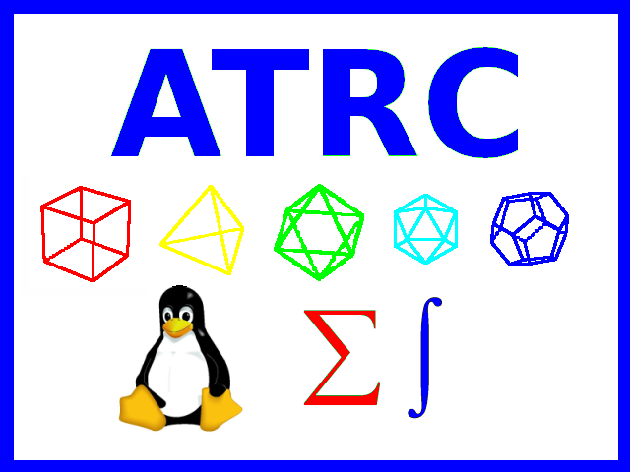
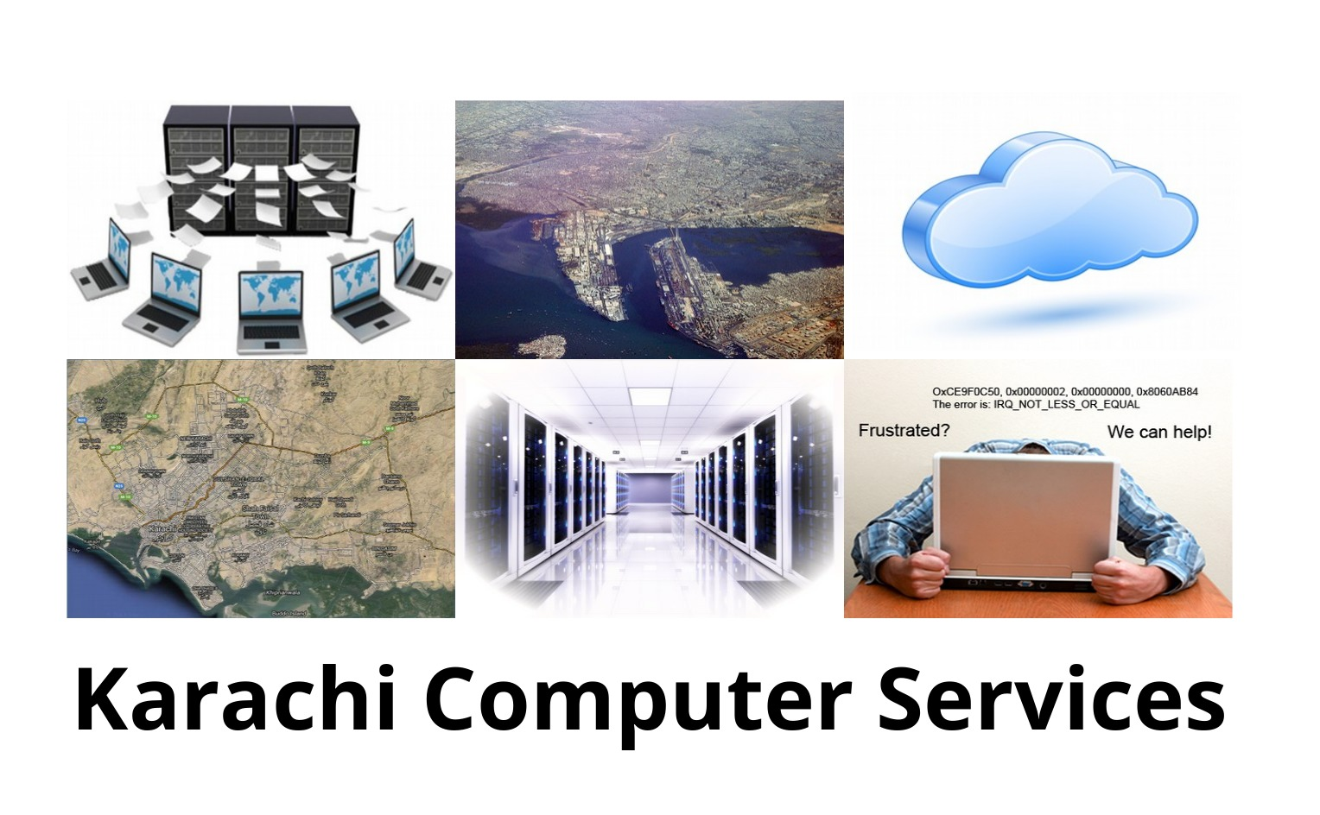

^{Technical Support}
Technical support or tech support refers to a range of services by which KCS provides assistance to its clients and users of technology products such as mobile phones, televisions, computers, software products or other electronic or mechanical goods. In general, technical support services attempt to help the user solve specific problems with a product—rather than providing training, customization, or other support services. We offer technical support for the products we sell and for products from other companies for a fee. Technical support may be delivered at the location or over the telephone or online by e-mail or a website or a tool where users can log a call/incident. Larger organizations frequently have internal technical support available to their staff for computer related problems. KCS can assist the internal support departments with access to experts which may not be available internally.

KCS Support Severity Level Definitions

Opening a support case online can make it easier to share technical data, error messages, and system information with your KCS Support representative. Following the online submission with a phone call can reduce response time as well as potential errors in the capture of information.

KCS recommends that you follow any Severity 1 and 2 online support case submissions with a phone call to the support center.

KCS Support Services use the following definitions to classify issues:

Severity 1 (urgent)

A problem that severely impacts your use of the software in a production environment (such as loss of production data or in which your production systems are not functioning). The situation halts your business operations and no procedural workaround exists.

Severity 2 (high)

A problem where the software is functioning but your use in a production environment is severely reduced. The situation is causing a high impact to portions of your business operations and no procedural workaround exists.

Severity 3 (medium)

A problem that involves partial, non-critical loss of use of the software in a production environment or development environment. For production environments, there is a medium-to-low impact on your business, but your business continues to function, including by using a procedural workaround. For development environments, where the situation is causing your project to no longer continue or migrate into production.

Severity 4 (low)

A general usage question, reporting of a documentation error, or recommendation for a future product enhancement or modification. For production environments, there is low-to-no impact on your business or the performance or functionality of your system. For development environments, there is a medium-to-low impact on your business, but your business continues to function, including by using a procedural workaround.

Coverage of support

Technical support may be delivered by different technologies depending on the situation. For example, direct questions can be addressed using telephone calls, SMS, Online chat, Support Forums, E-mail or Fax; basic software problems can be addressed over the telephone or, increasingly, by using remote access repair services; while more complicated problems with hardware may need to be dealt with in person.

Types of Technical Support

(CALL OUT)

This type of technical support is very common in the services industry. It is also known as "Break-Fix" IT Support. The concept behind this type of support is that the customer pays for the materials (Hard Drive, Memory, Computer, etc.) as well as pays the technician based on their pre-negotiated rate when they have a problem.

Block Hours (SLA)

Block Hours is basically a way to purchase a bunch of hours upfront to pay a reduced hourly rate. The premise behind this type of support is that the customer has negotiated a discounted rate and a fixed number of hours to use either per month or year. This allows them the flexibility to use the hours as they please without doing the paperwork and the hassle of paying multiple bills.

Managed Services

Managed Services means a company will receive a list of well-defined services on an ongoing basis, with well-defined "response and resolution times" for a fixed rate or a flat fee. This can include things like 24/7 Monitoring of Servers, 24/7 Help desk for your daily computer issues and On-site visits by a technician when issues cannot be resolved remotely. Some companies also offer additional services like Project Management and Vendor management in the monthly price.

Outsourcing technical support

With the increasing use of technology in modern times, there is a growing requirement to provide technical support. Many organizations locate their technical support departments or call centers in countries or regions with lower costs. There has also been a growth in companies specializing in providing technical support to other organizations. These are often referred to as MSP's (Managed Service Providers).

For businesses needing to provide technical support, outsourcing allows them to maintain a high availability of service. Such need may result from peaks in call volumes during the day, periods of high activity due to introduction of new products or maintenance service packs, or the requirement to provide customers with a high level of service at a low cost to the business. For businesses needing technical support assets, outsourcing enables their core employees to focus more on their work in order to maintain productivity. It also enables them to utilize specialized personnel whose technical knowledge base and experience may exceed the scope of the business, thus providing a higher level of technical support to their employees.

If you need us to help design your internal support department with an outsourced service provider, then we are here to help. Our support can avail lower cost labor from the subcontinent. We can also hire and place people on contract in your organization.

Multi-tiered technical support

Technical support is often subdivided into tiers, or levels, in order to better serve a business or customer base. The number of levels a business uses to organize their technical support group is dependent on a business’ need, want, or desire as it revolves around their ability to sufficiently serve their customers or users. The reason for providing a multi-tiered support system instead of one general support group is to provide the best possible service in the most efficient possible manner. Success of the organizational structure is dependent on the technicians’ understanding of their level of responsibility and commitments, their customer response time commitments, and when to appropriately escalate an issue and to which level. A common support structure revolves around a three-tiered technical support system.

Tier/Level 1 (T1/L1)

This is the initial support level responsible for basic customer issues. It is synonymous with first-line support, level 1 support, front-end support, support line 1, and various other headings denoting basic level technical support functions.The first job of a Tier I specialist is to gather the customer’s information and to determine the customer’s issue by analyzing the symptoms and figuring out the underlying problem.When analyzing the symptoms, it is important for the technician to identify what the customer is trying to accomplish so that time is not wasted on "attempting to solve a symptom instead of a problem." Once identification of the underlying problem is established, the specialist can begin sorting through the possible solutions available. Technical support specialists in this group typically handle straightforward and simple problems while "possibly using some kind of knowledge management tool." This includes troubleshooting methods such as verifying physical layer issues, resolving username and password problems, uninstalling/reinstalling basic software applications, verification of proper hardware and software set up, and assistance with navigating around application menus. Personnel at this level have a basic to general understanding of the product or service and may not always contain the competency required for solving complex issues. Nevertheless, the goal for this group is to handle 70%-80% of the user problems before finding it necessary to escalate the issue to a higher level.

Tier/Level 2 (T2/L2)

This is a more in-depth technical support level than Tier I and therefore costs more as the techs are more experienced and knowledgeable on a particular product or service. It is synonymous with level 2 support, support line 2, administrative level support, and various other headings denoting advanced technical troubleshooting and analysis methods. Technicians in this realm of knowledge are responsible for assisting Tier I personnel in solving basic technical problems and for investigating elevated issues by confirming the validity of the problem and seeking for known solutions related to these more complex issues. However, prior to the troubleshooting process, it is important that the technician review the work order to see what has already been accomplished by the Tier I technician and how long the technician has been working with the particular customer. This is a key element in meeting both the customer and business needs as it allows the technician to prioritize the troubleshooting process and properly manage his or her time. If a problem is new and/or personnel from this group cannot determine a solution, they are responsible for raising this issue to the Tier III technical support group. In addition, many companies may specify that certain troubleshooting solutions be performed by this group to help ensure the intricacies of a challenging issue are solved by providing experienced and knowledgeable technicians. This may include, but is not limited to onsite installations or replacements of various hardware components, software repair, diagnostic testing, and the utilization of remote control tools used to take over the user’s machine for the sole purpose of troubleshooting and finding a solution to the problem.

Tier/Level 3 (T3/L3)

This is the highest level of support in a three-tiered technical support model responsible for handling the most difficult or advanced problems. It is synonymous with level 3 support, back-end support, support line 3, high-end support, and various other headings denoting expert level troubleshooting and analysis methods. These individuals are experts in their fields and are responsible for not only assisting both Tier I and Tier II personnel, but with the research and development of solutions to new or unknown issues. Note that Tier III technicians have the same responsibility as Tier II technicians in reviewing the work order and assessing the time already spent with the customer so that the work is prioritized and time management is sufficiently utilized.If it is at all possible, the technician will work to solve the problem with the customer as it may become apparent that the Tier I and/or Tier II technicians simply failed to discover the proper solution. Upon encountering new problems, however, Tier III personnel must first determine whether or not to solve the problem and may require the customer’s contact information so that the technician can have adequate time to troubleshoot the issue and find a solution.In some instances, an issue may be so problematic to the point where the product cannot be salvaged and must be replaced. Such extreme problems are also sent to the original developers for in-depth analysis. If it is determined that a problem can be solved, this group is responsible for designing and developing one or more courses of action, evaluating each of these courses in a test case environment, and implementing the best solution to the problem.Once the solution is verified, it is delivered to the customer and made available for future troubleshooting and analysis.

Tier/Level 4 (T4/L4)

While not universally used, a fourth level often represents an escalation point beyond the organization. This is generally a hardware or software vendor. Within a corporate incident management system it is important to continue to track incidents even when they are being actioned by a vendor and the Service Level Agreement (SLA) may have specific provision for this.

PRODUCT SUPPORT LEVELS

PSL6 KCS Strategic Solution Offering
These products form the foundation of our operations, and they're considered to be among our core competency. When a product is assigned a PSL6 Status, it indicates that we have:
- significant research and investment in the product
- long history and experience through active usage in-house
- authoritative knowledge on the product
- formal strategic alliance and with the vendor, and
- long-term commitment to the platform.
PSL5 Officially Supported: Actively used or installed in-house, walk-thru available, up-to-date on versions, problems, news & development, etc.
PSL4 Supported: Trained on product, but not keeping up on development. Do not maintain in-house installed copies.
PSL3 Assisted: Only basic familiarity with product.
PSL 2 Unknown: No knowledge on product. Can research on client's behalf.
PSL 1 Unsupported: No support. We decline to work on such product due to known insurmountable issues, or specific concern/objections from past experience.

KCS and Vendor support levels
VSL6 KCS Strategic Solution Offering
Officially Supported: Official support from vendor. KCS is supporting and integrating as a partner of the main vendor.
Even if the main vendor stops offering services, KCS shall continue to support the product.
These products form the foundation of our operations, and they're considered to be among our core competency. When a product is assigned a VSL6 Status, it indicates that we have:
- significant research and investment in the product
- long history and experience through active usage in-house
- authoritative knowledge on the product
- formal strategic alliance and with the vendor, and
- long-term commitment to the platform.
VSL5 Officially Supported: Official support from vendor. KCS is supporting and integrating as a partner of the main vendor.
VSL4 Supported: Official support from vendor. KCS is supporting and integrating as a third party.
VSL3 No main vendor support. Support may be available from other sources. KCS may be able to support after researching possibilities.
VSL 2 No vendor support. No knowledge on product. Can research on client's behalf.
VSL 1 Unsupported by vendor and not supported by KCS. No support. We decline to work on such product due to known insurmountable issues, or specific concern/objections from past experience.

Remote PC repair or Remote Computer Repair

Remote PC repair or Remote Computer Repair is a method for troubleshooting software related problems via remote desktop connections. Technicians use software that allows the technician to access the user's desktop via the Internet. With the user's permission, the technician can take control of the user's mouse and keyboard, transfer various diagnostic and repair applications to the user's desktop, run scans, install antivirus programs, etc. If the remote service permits it, the technician can even reboot the PC and reconnect remotely to continue his work without the user needing to assist.

Common repairs available with online computer support providers are computer virus and spyware removal, computer optimization, Windows Registry repair, device driver issues, Web related issues, and Windows security updates.

Only software can be "repaired" remotely. A computer with a broken hardware component such as a motherboard or hard disk can in some cases be diagnosed and worked around, but must be repaired in person.

Software support services
- Installation
- Usage
- Configuration
- Diagnosis
- Bug reports
- Bug fixes for software developed or maintained by KCS.
- Software modified by KCS
- Third-party software/drivers and uncertified hardware/hypervisors supported by KCS
- Community projects upon which other releases are based
- Code development
- System and network design
- Implementation and development of security rules and policies
- Technology preview features or beta software.

Contact for details

tech-support-request@atrc.net.pk

or call +92 331 2036 422

