

Business Comprehension TM : ERP & SCM Services
Welcome to Business Comprehension TM, your trusted partner for comprehensive ERP and SCM services. Our cutting-edge solutions empower businesses to streamline operations, enhance productivity, and optimize supply chain management.

Enterprise Resource Planning (ERP)

1. Integrated Modules
- Finance and Accounting
- Human Resources
- Sales and Marketing
- Inventory Management
- Project Management

2. Real-time Analytics
Leverage data-driven insights for informed decision-making and business intelligence.

3. Customization
Tailor our ERP system to meet the unique needs of your business.

4. Scalability
Grow your business with confidence, as our ERP system scales seamlessly.

Supply Chain Management (SCM)

1. End-to-End Visibility
Monitor and control every aspect of your supply chain in real time.

2. Inventory Optimization
Reduce costs and improve efficiency with optimized inventory management.

3. Supplier Collaboration
Strengthen relationships and enhance collaboration with suppliers.

4. Order Fulfillment
Streamline order processing and enhance customer satisfaction.

Why Choose Business Comprehension TM Solutions?
- Proven Expertise: With years of experience, we have successfully implemented ERP and SCM solutions for diverse industries.
- Customer-Centric Approach: Our solutions are tailored to meet the unique needs of each client, ensuring maximum value.
- 24/7 Support: Our dedicated support team is available around the clock to address your queries and concerns.
- Future-Ready Technology: Stay ahead in the digital landscape with our innovative and future-ready technologies.

Get Started Today!
Transform your business with Business Comprehension TM services. Contact us today for a consultation and take the first step toward achieving operational excellence.

Phone: +92 343 270 2932
Email: erp@atrc.net.pk
Website: http://atrc.net.pk/

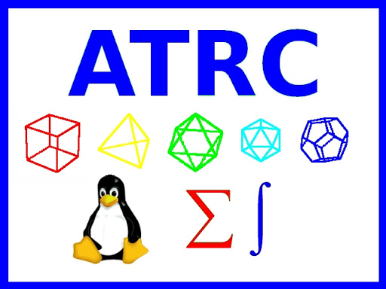
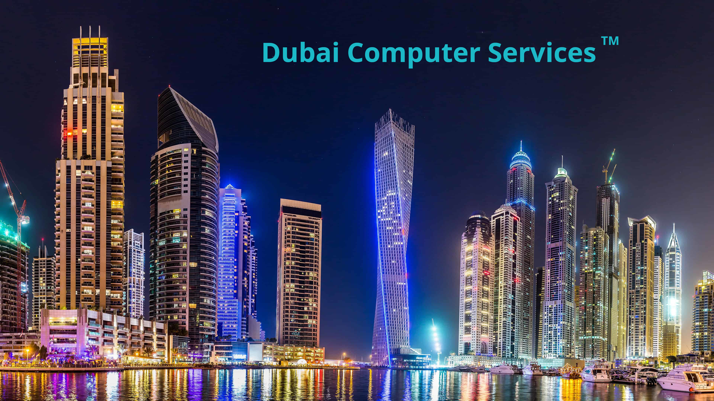
Business Comprehension TM and Dubai Computer Services TM is a part of ATRC.

