

MuftaSoft TM Endows 11.3

64 Bits for Intel and AMD PCs
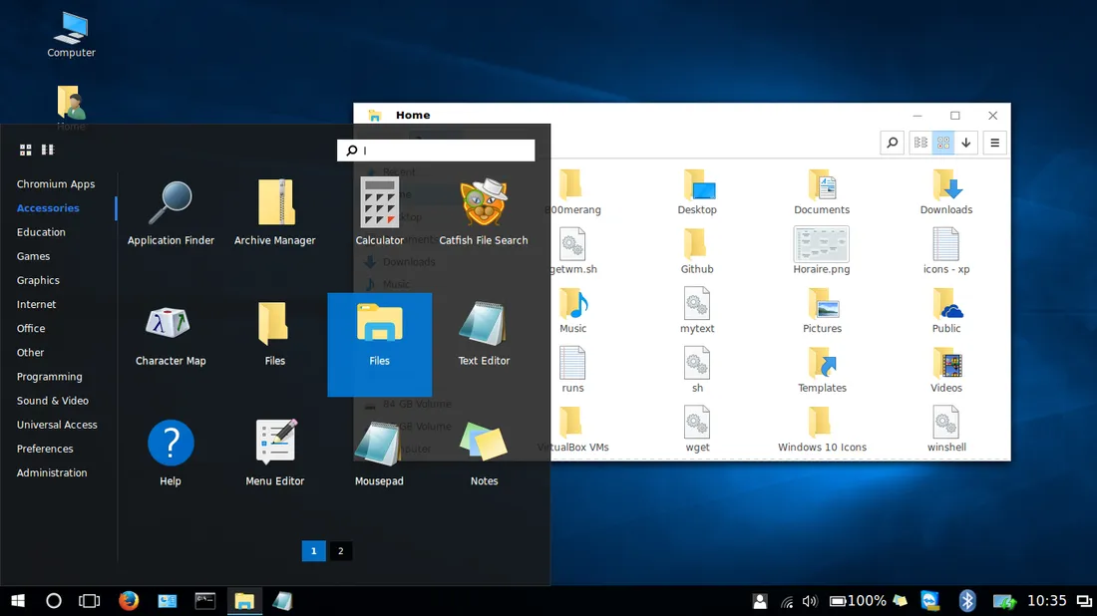

Meet the new Endows 11.3 Professional:
- Helloa Virtual Assistant who understands you, executes commands and searches for you.
- Microsoft PowerShell is a default terminal.
- Kernel install tool for easy one click kernel update.
- Ready for Microsoft teams, skype, edge, code and more.
- Ready for Google Drive and OneDrive cloud and more.
- Completely compatible with Microsoft Office documents.
- All WxDesktop features available with real-time updates
- Full support for Microsoft Active Directory and Worgroups networks (same Microsoft © Windows® configuration panel).

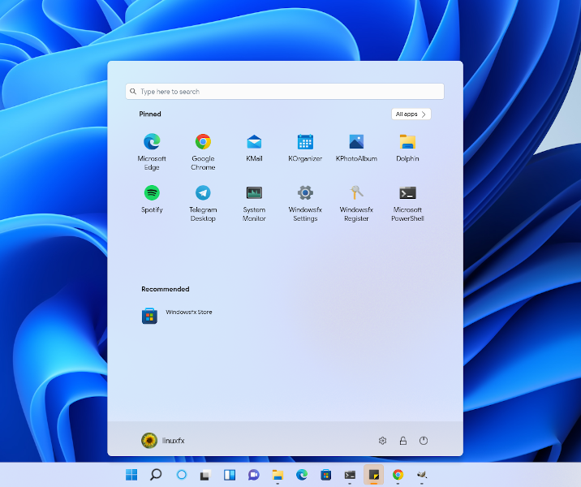

- Integration with Smart Home (google home, arduino and GP-IO)
- Latest build of the system core (kernel) to better support your computer's drivers.
- Improved support for Microsoft © Windows® applications.
- Support for games developed for Microsoft © Windows®.
- Advanced support for VDI (VMware Horizon, Citrix Receiver, Remote Desktop, etc...)
- Cinnamon Desktop Edition ISO for 2 cores 2 GB memory computer or more.
- Plasma Desktop Edition ISO for 2 cores 2 GB memory computer or more.
Download link

